T3 series test instructions

Content

1.Wiring instruction 1
2.Wi-Fi fixed frequency test 2
3.BLE fixed frequency test 8
4.Wi-Fi adaptive test 11
5.BLE RX Blocking test (Signaling) 15

1.Wiring instruction
1.1 Module welding position
T3-2S T3-3S T3-E2
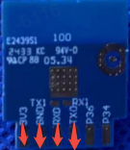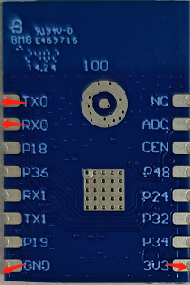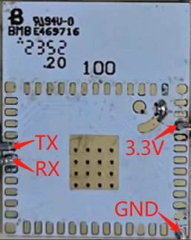
T3-M、T3-M-IPEX T3-U、T3-U-IPEX T3-V-PRO
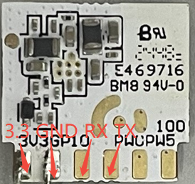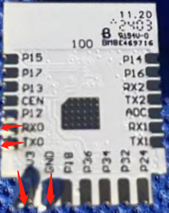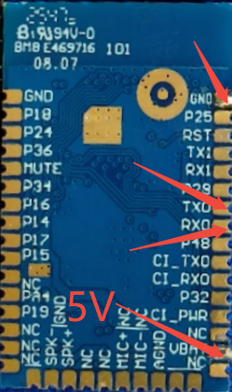
1.2 Fixed frequency module --Connect -- UART Board(TX\RX is reversed)
3V3 ------------------------------------- 3.3V (T3-V-PRO VBAT Connect UART 5V)
GND ------------------------------------ GND
RX0 --------------------------------------- TX
TX0 ---------------------------------------- GND
After the UART board is plugged into the PC, Module TX0 connects to UART RX
1.3 For example: T3-3S
Double click to watch video

2.Wi-Fi fixed frequency test
2.1 After connecting the fixed frequency module as described above, download the UART driver
UART driver：(The computer recognizes COM, you can not install the driver)
(Double click to download)
2.2 Use the Wifi Test Tool v1.7.8.1
(Double click to download)
2.3 Open the tool , select COM, Baud Rate: 115200, click Connect Port, IDLE becomes OK
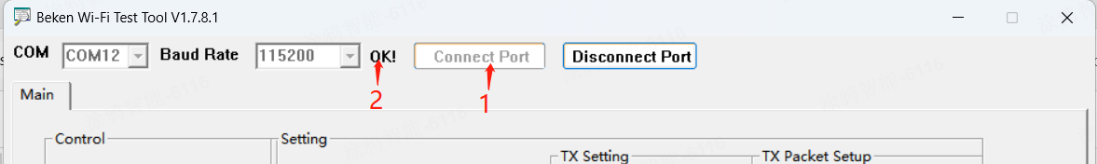
2.4 Next, you can change Standard, Bandwidth, Data Rate, Channel, Select WiFi-Tx, and press Start to test
FCC/SRRC need to select FCC, CE or SRRC, and other tests to be FALSE. Temp Cali : FALSE.
(Do not click SAVE IN FLASH throughout the test.)
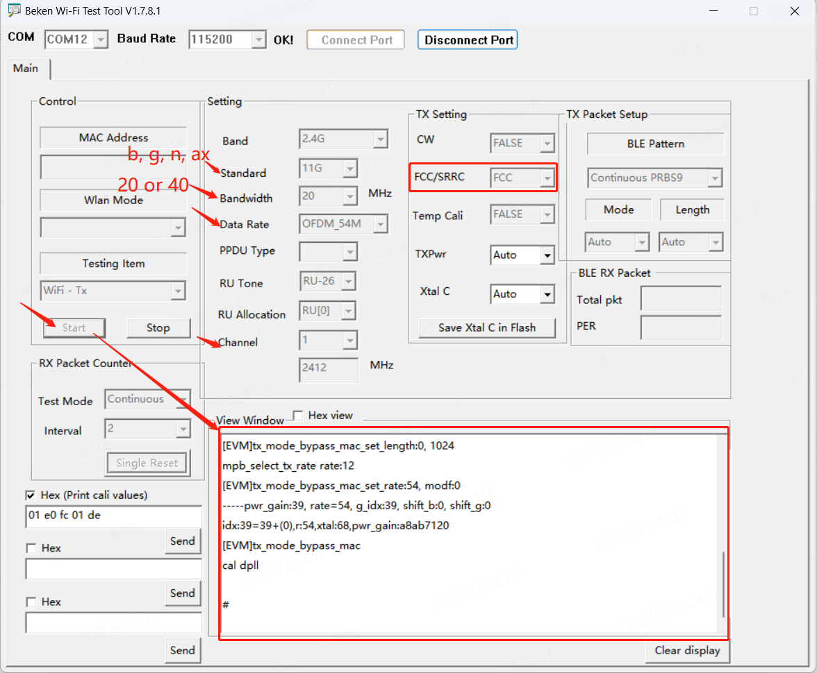
2.5 If you need to adjust the power, change the TX Pwr value to adjust the power. If the test value does not change after modification, click stop and then click start to test.
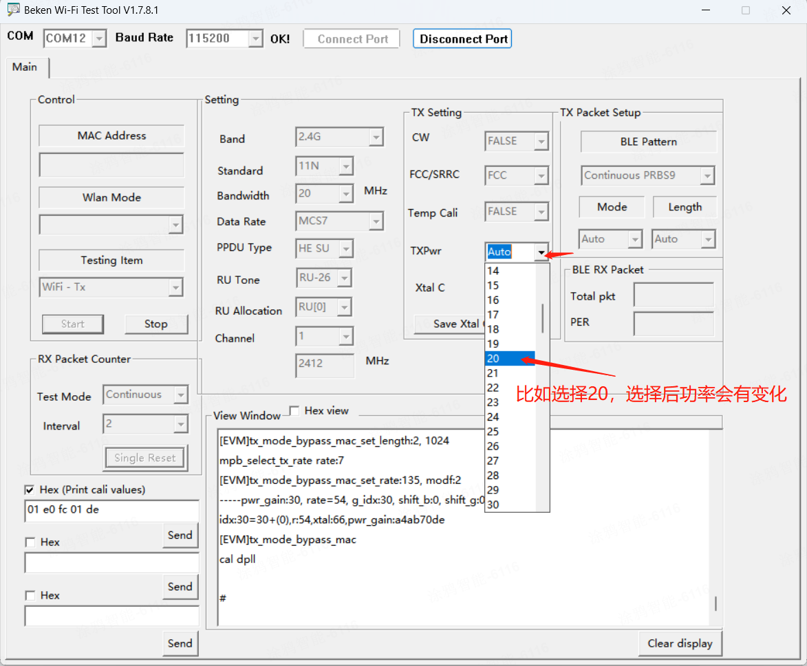
Adjust the TXPwr: log
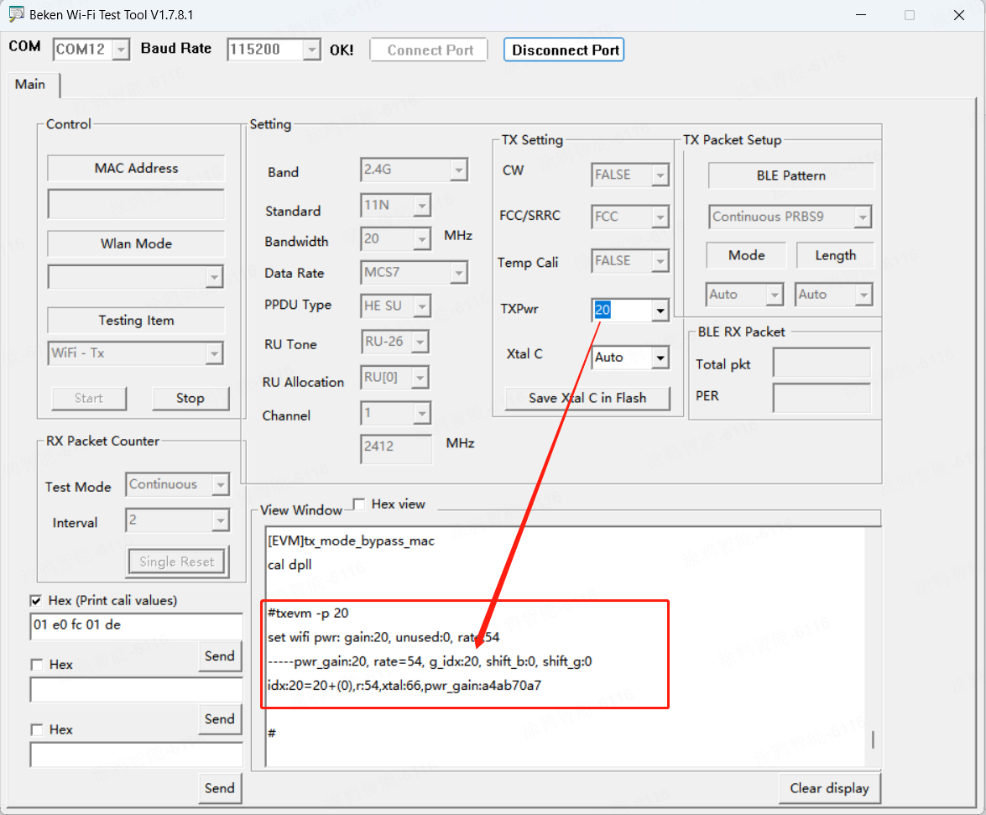
2.6 Wi-Fi Single Tone Test: TX setting CW selects TRUE, then Testing Item selects WiFi-TX, click Start to test.
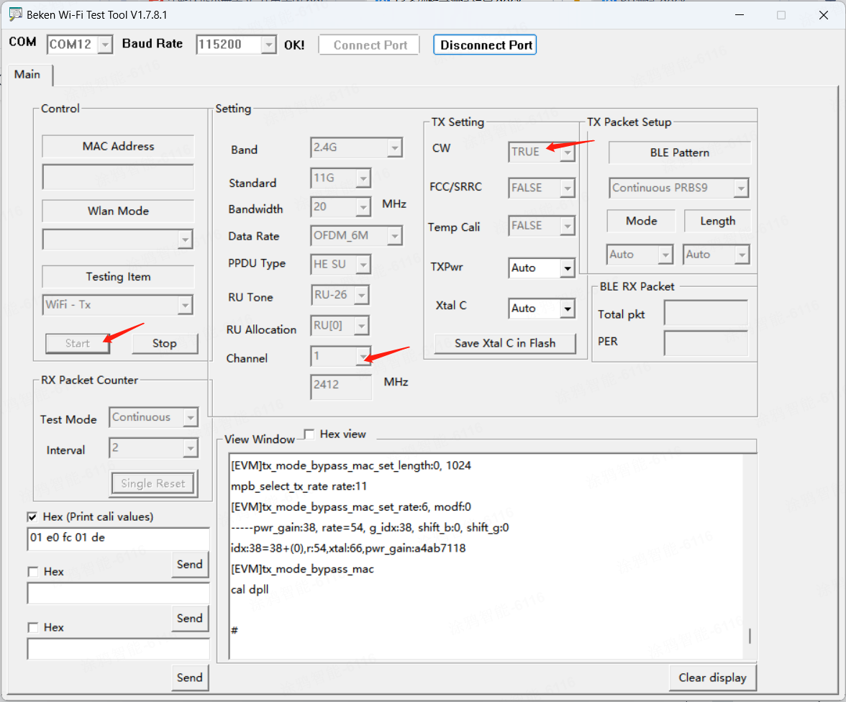
If the test fails, adjust the Xtal C value to test.
For Example: select 10, Log：
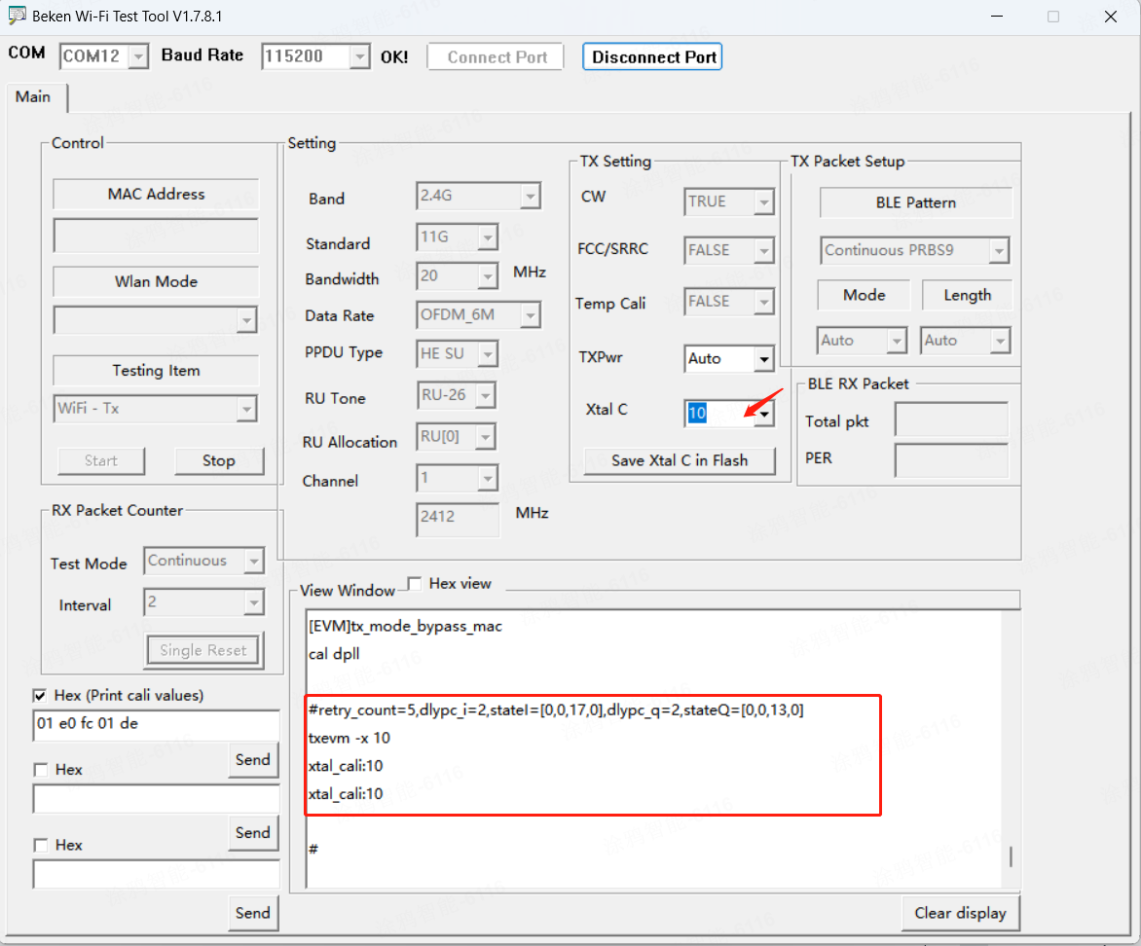
2.7 Wi-Fi RU Test
Use TUYA's instruments to illustrate the test method.During the actual certification,Test with the instrument of the testing institution
1）Set Standard to 11AX and PPDU Type to HE-TB, as shown in the figure：
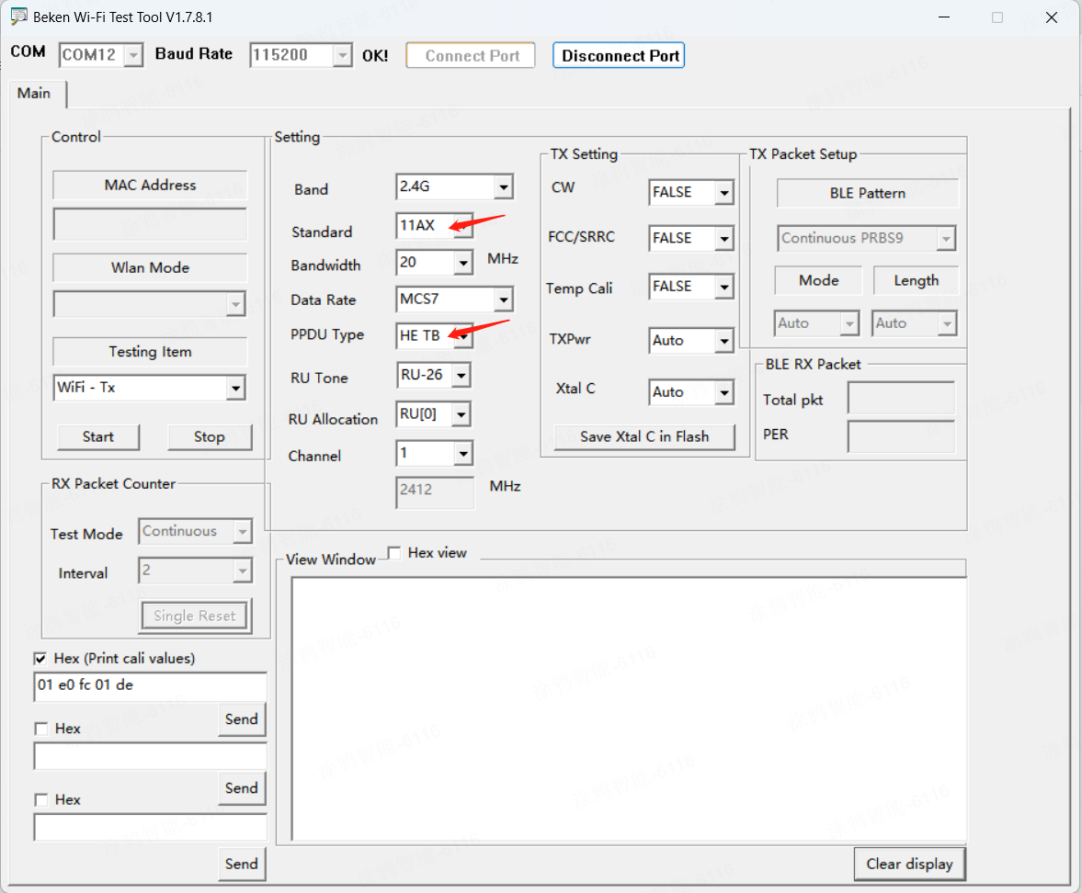
2）First, connect itest and open itest test software, as shown in the figure：
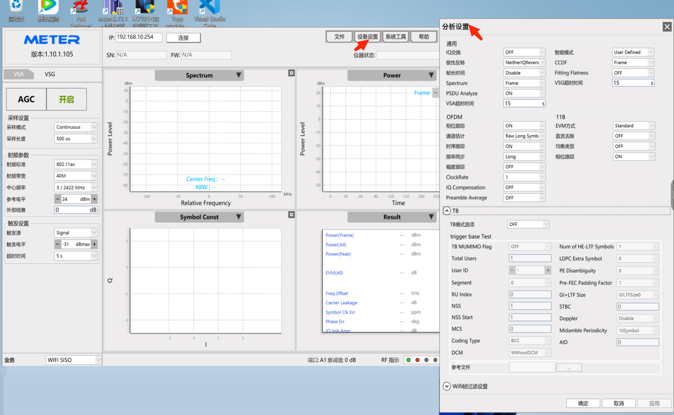
Upper-right 设备设置->”分析设置”，Follow the Settings in the image below：
RU Index corresponds to RU Allocation in V1.7.8.1, and MCS corresponds to Data Rate in V1.7.8.1. This parameter must be consistent with the software Settings；
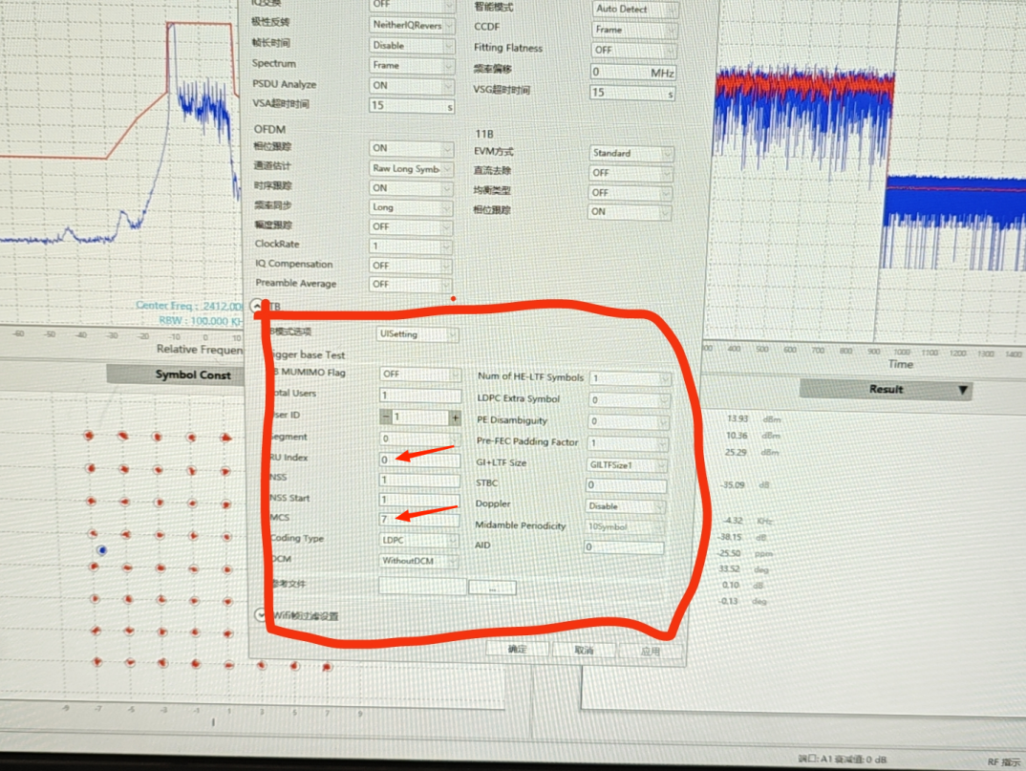
Such as, the Data Rate Settings are the same: MCS7;The RU Allocation Settings are the same: 0
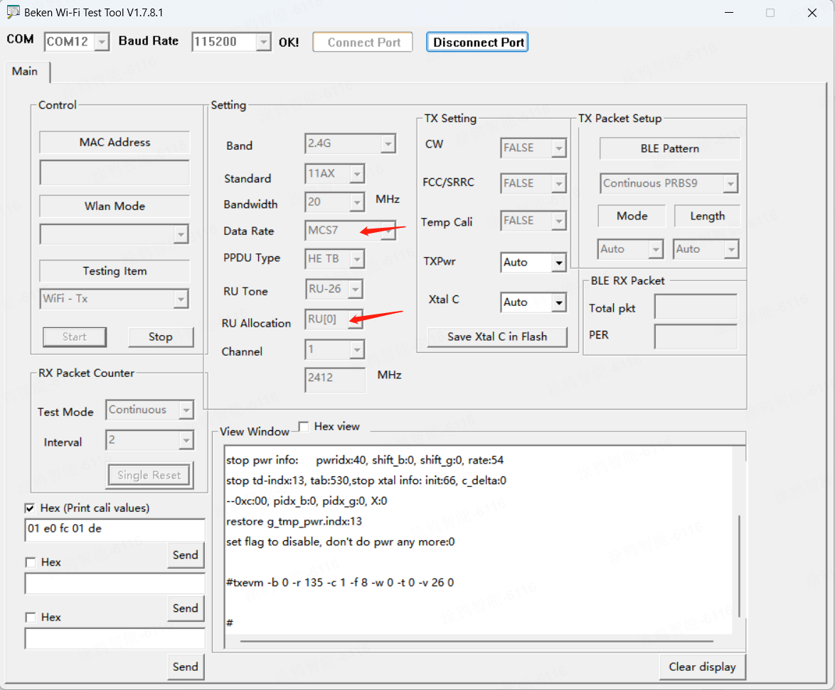
3）By clicking start, itest can parse Wi-Fi 11AX's signal normally. If the test fails, you can manually set TXPwr, the range is 0~20 (it is determined according to the absolute power, the maximum transmission power of the chip is 20dbm, so the maximum tool can only be set to 20, more than 20 is invalid)

2.8 Wi-Fi RX test
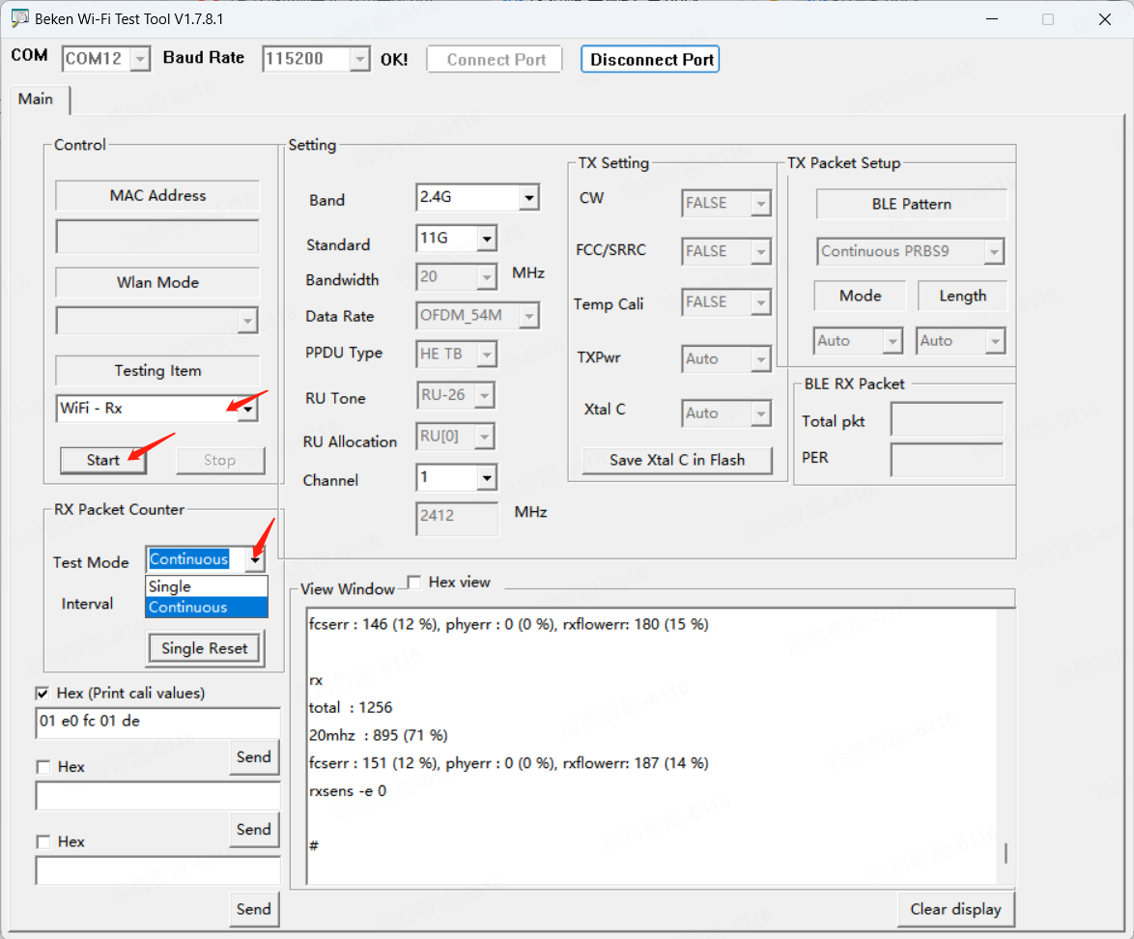

3.BLE fixed frequency test
3.1 The module is connected to the UART according to the wiring instructions. Open the tool, connect the port.
3.2 Select Bluetooth-TX,BLE patter select Continuous PRBS9 or Burst PRBS9, change Channel, Rate(support LE1M, S8, S2), TXPwr default Auto, click Start；If you need to adjust the power, change the TxPwr value；
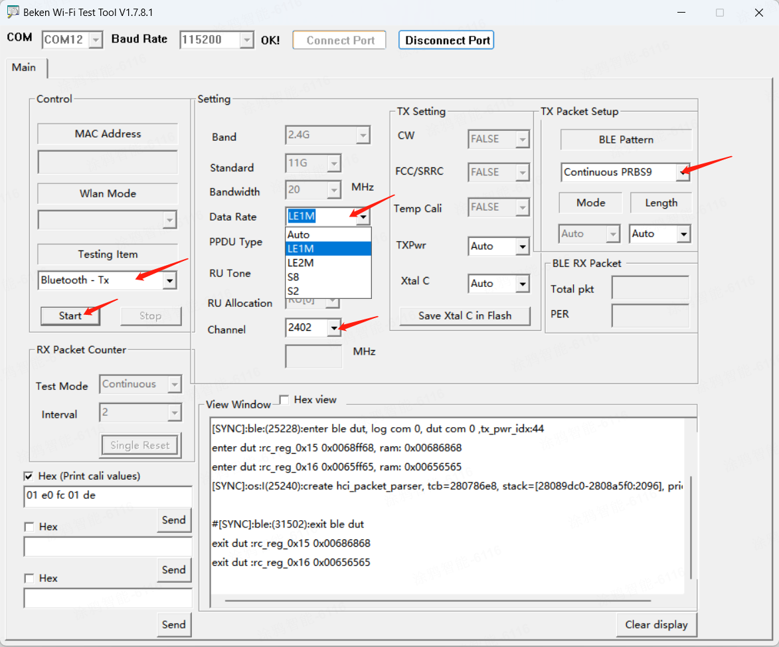
3.3 BLE Frequency error:Testing Item select Bluetooth-Tx,BLE pattern select Continuous wave, change Channel, click Start to test.
3.4 BLE RX: select Bluetooth-Rx, click Start to test.
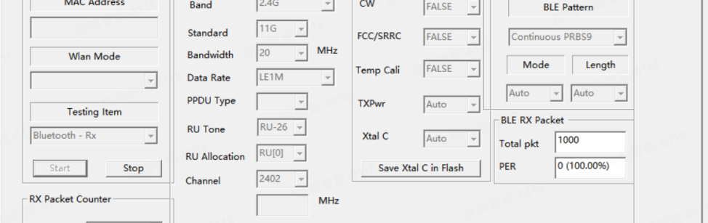
Or can run commands to test BLE RX
- The fixed frequency module connects to the UART, insert the PC, Use the SSCOM
Double click to download
- Open the SSCOM tool, perform the following steps: Click EXT to appear the command
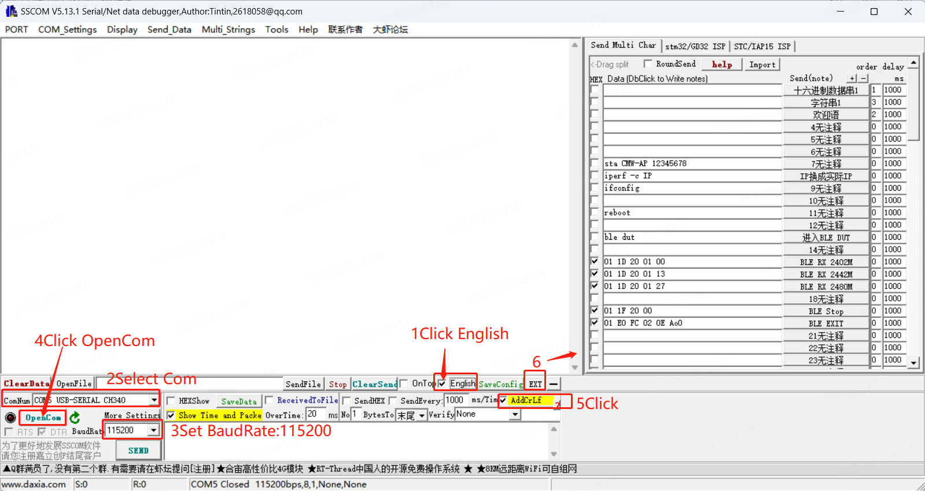
- Click "进入BLE DUT" to send the command：ble dut. As shown below
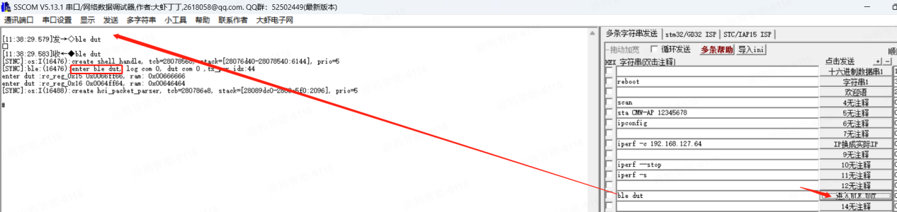
- Click HEXshow, click “BLE RX 2402M” to send CH0; Send channel according to the actual test
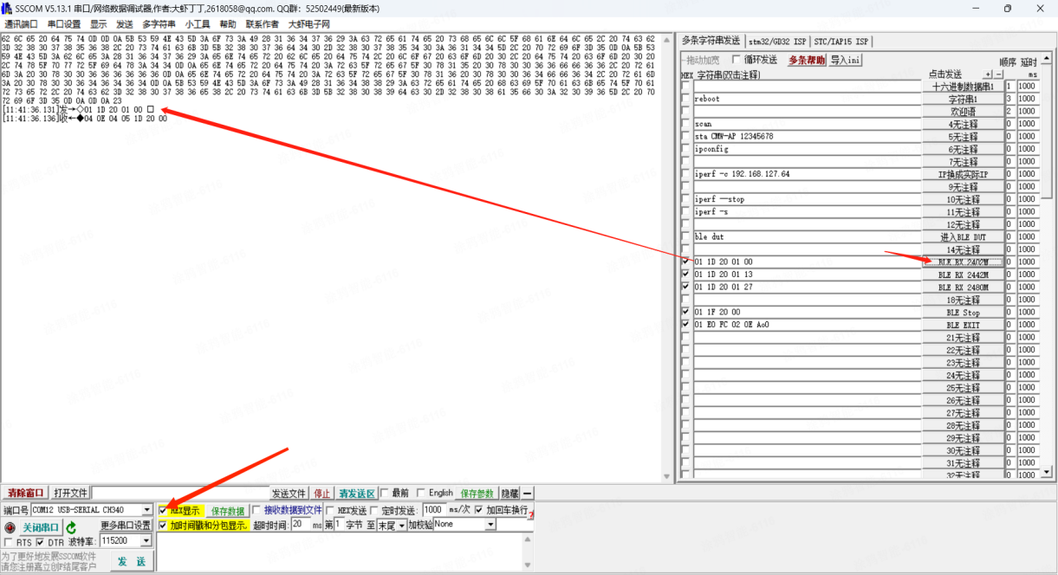
- Then use the signal source to send 1M mode, single transmission, 1000 packets at a time
Finally click “BLE stop”
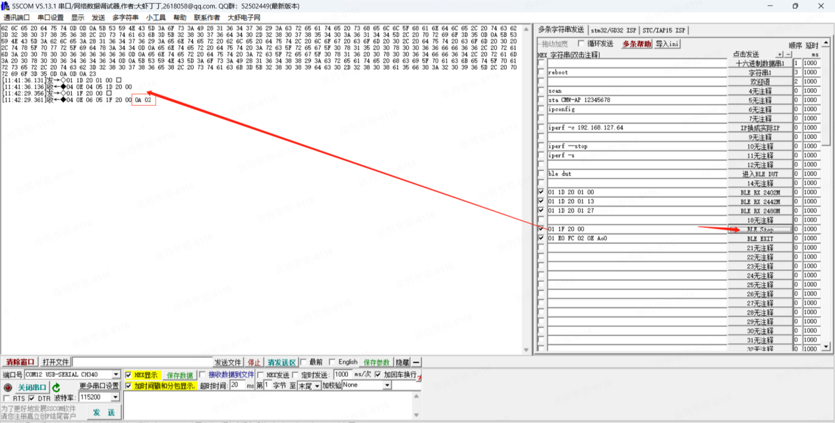
As shown above,clicking Ble stop, the last four digits of the returned hexadecimal number are 0A 02, then the actual number of packets received is calculated as 0x02*256+0x0A,it is 522 packets
as shown above
- Test CH0 in the following figure, the last four digits are 7D 03, and the number of packets received is 893
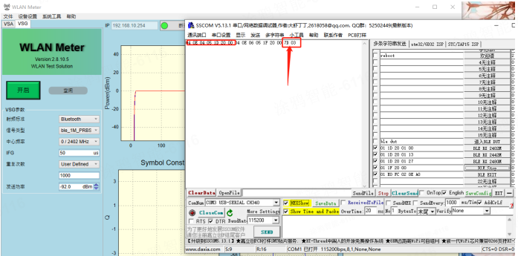
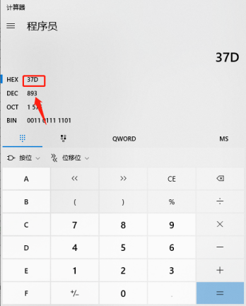

4.Wi-Fi adaptive test
4.1 The module is connected to the UART according to the wiring instructions.
4.2 Use the SSCOM tool
Double click to download tool
4.3 Open the SSCOM tool and follow steps 1-6: Click EXT to appear the command
4.4 Send command(sta ssid psk) to connect to the router
sta ssid psk //ssid：router name psk :router password
For example：sta CMW-AP 12345678
4.5 Click "5无注释" to send the command: sta CMW-AP 12345678
Connection succeed; send command to view module IP: ipconfig
As shown in the figure Module IP: 192.168.127.233
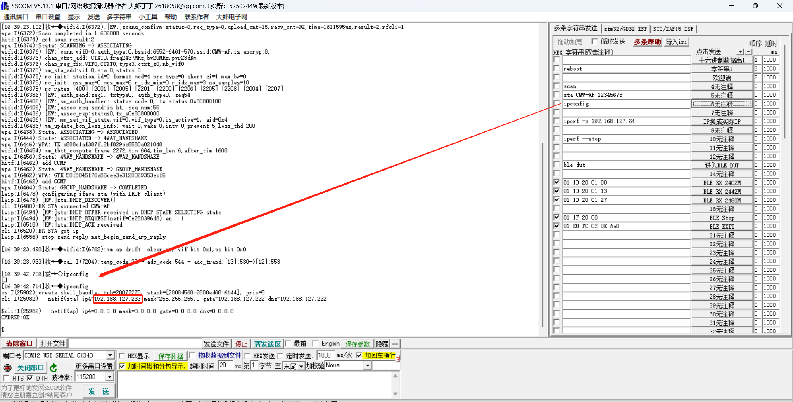
4.6 The PC (-c) connects to the same network. After the connection is successful, view the IP address through network properties. PC IP：192.168.178.64
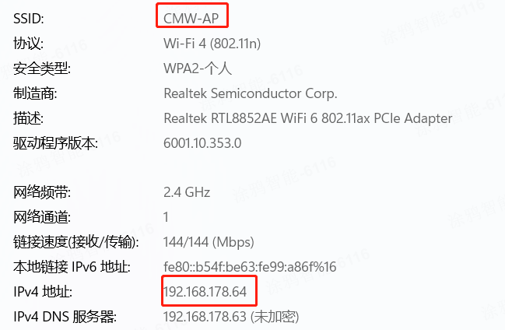
4.7 Download the iperf.zip
Double-click to download it to your desktop
4.8 Run cmd in administrator mode；
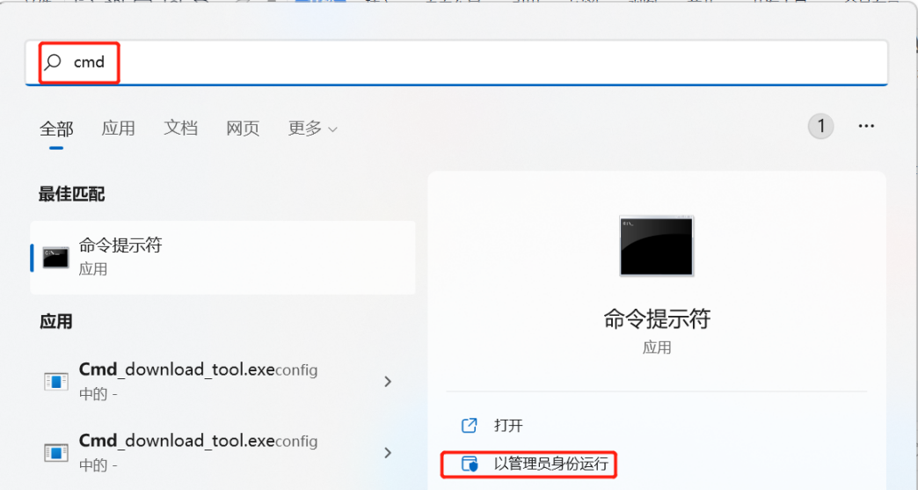
4.9 Find the following file in the iperf.Zip downloaded in Step 4.7；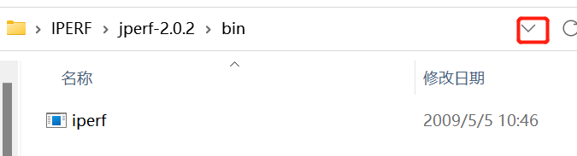
4.10 Click the down arrow to copy and paste the path; Then add cd in front of the path；
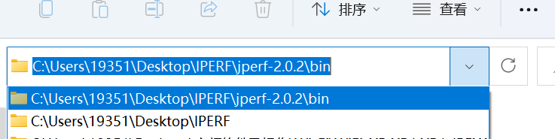
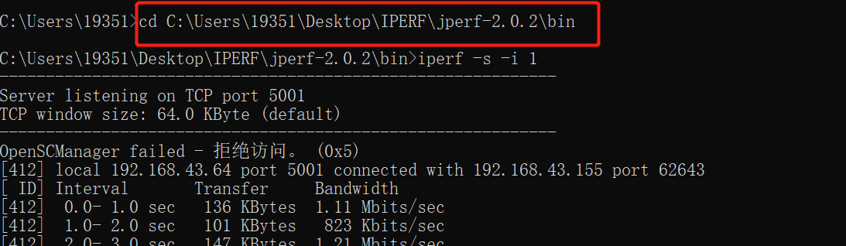
4.11 Send instruction: iperf -s -i 1；
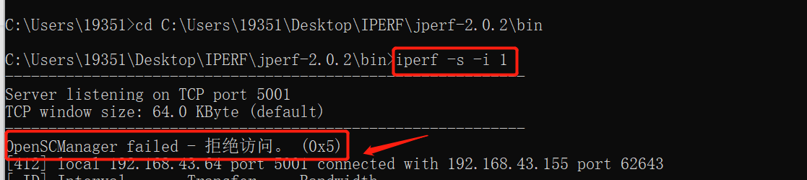
4.12 Module: SSCOM send command: iperf -c 192.168.178.64
The ip address is changed based on the actual PC address；
The default is always running. Stop sending command: iperf --stop
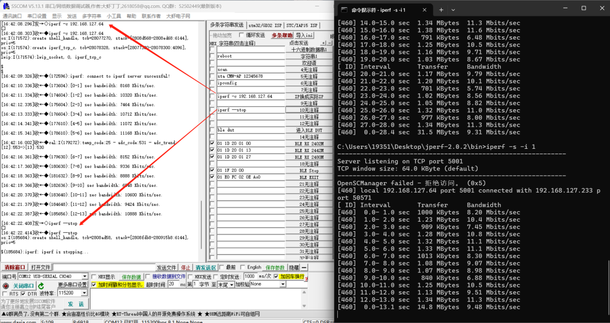
4.13 Module as receive, SSCOM: iperf -s, cmd（PC）：iperf -c Module IP
Module IP：192.168.178.233, so：iperf -c 192.168.178.233
The module IP address is subject to the actual test module IP address
The default is 10 packages
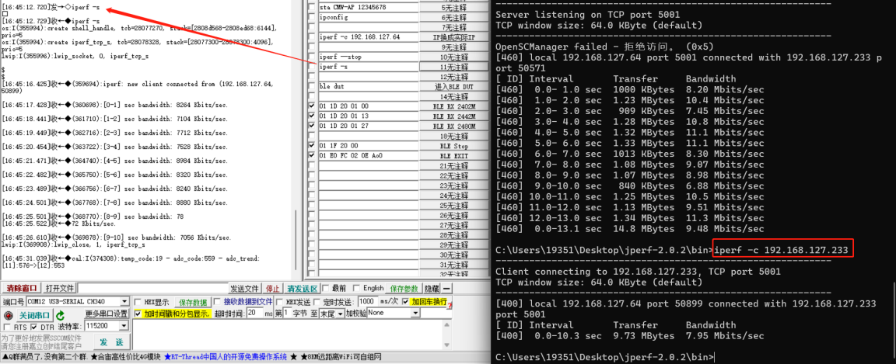
PC：iperf -c 192.168.127.233 -t 20 -i 1
20 can be changed to the number of packets required
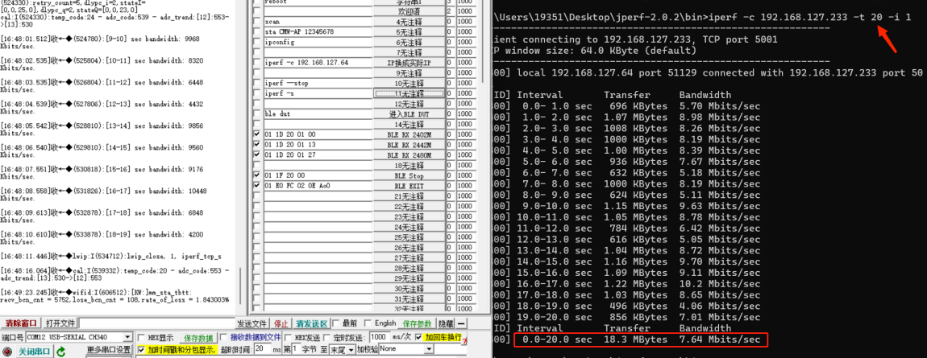

5.BLE RX Blocking test (Signaling)
5.1 Wiring as follows
Module ----- UART1 connect to the PC USB
GND ---- GND
RX0 ---- TX
TX0 ---- GND
Module ----- UART2 connect to the CMW500 USB
3V3 ---- 3.3V (T3-V-PRO VBAT Connect UART 5V)
GND ---- GND
After UART1 is connected to the computer and UART2 is connected to the CMW500, TX0 of UART1 is connected to the UART1 RX, and the power is kept on during the process
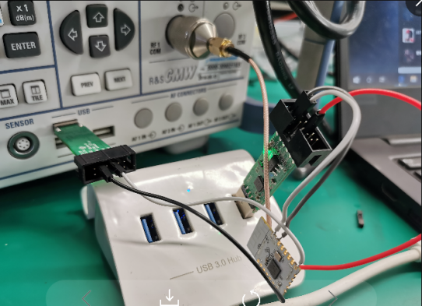
5.2 Click EXT to appear the command, click "进入BLE DUT" to send the command：ble dut
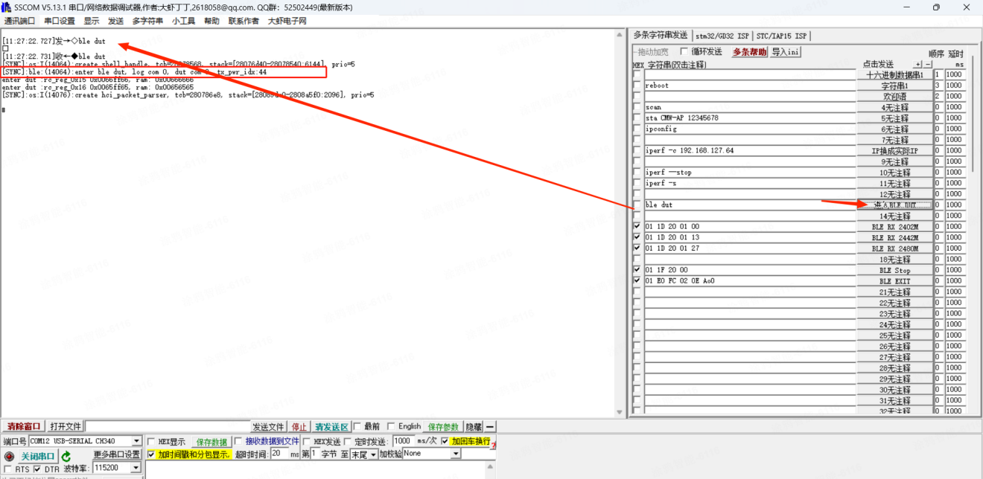
5.3 TX0 and RX0 are connected to the USB of the CMW, Don't cut off the power halfway
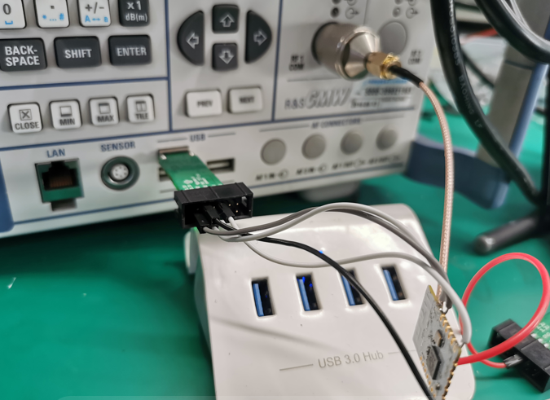
5.4 Operate CMW500 Signaling test RX Blocking，setting as below：
