BDU

I. Fixed Frequency Testing 1
II. BQB Testing 4

I. Fixed Frequency Testing
1. Wiring Instructions
Module ------ Serial Port Board
VCC ------- 3.3V
GND ------- GND
IO22 ------- TX
IO20 ------- RX
2. Testing with Btool
Right-click to download and save to file
If unable to test after the above download, download Btool from:
https://www.ti.com/tool/SIMPLELINK-LOWPOWER-SDK
Btool tool is located at the installation path:
D:\ti\simplelink_lowpower_f3_sdk_9_12_00_19\tools\ble\btool
- Open Btool tool: Device->new device->OK
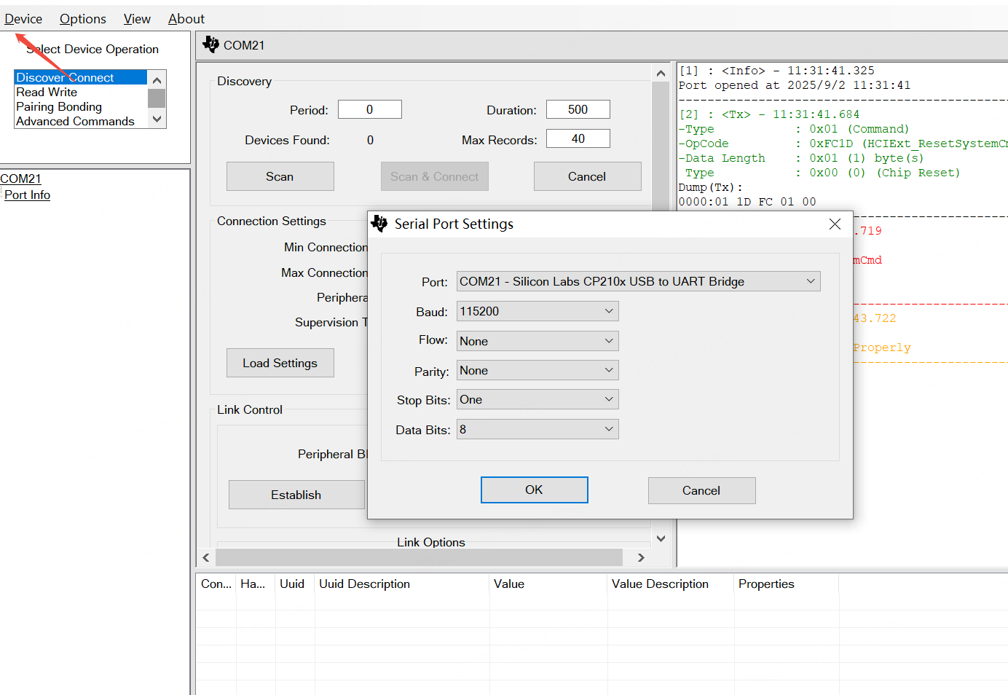
4. Click Advanced Commands and find HCI
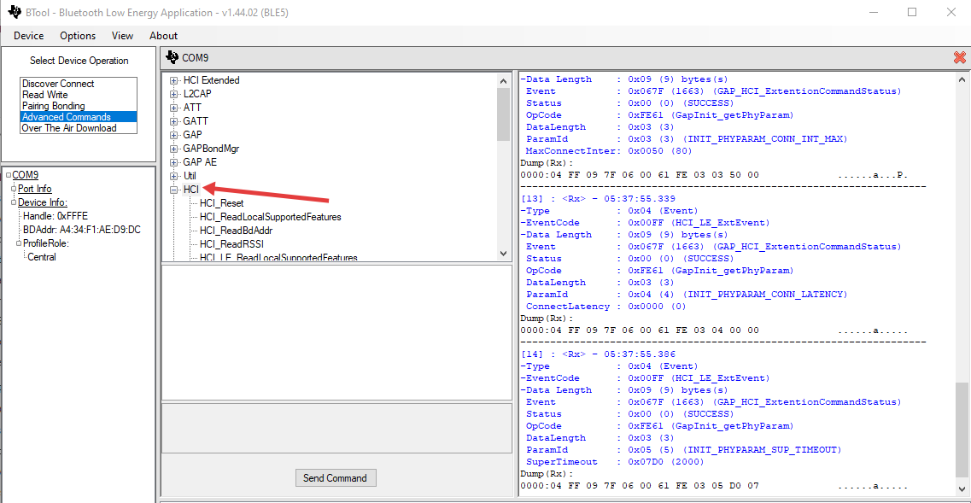
5. Transmit Test: HCI_LE_EnhancedTransmitterTest, set the channel and data rate, click Send Command
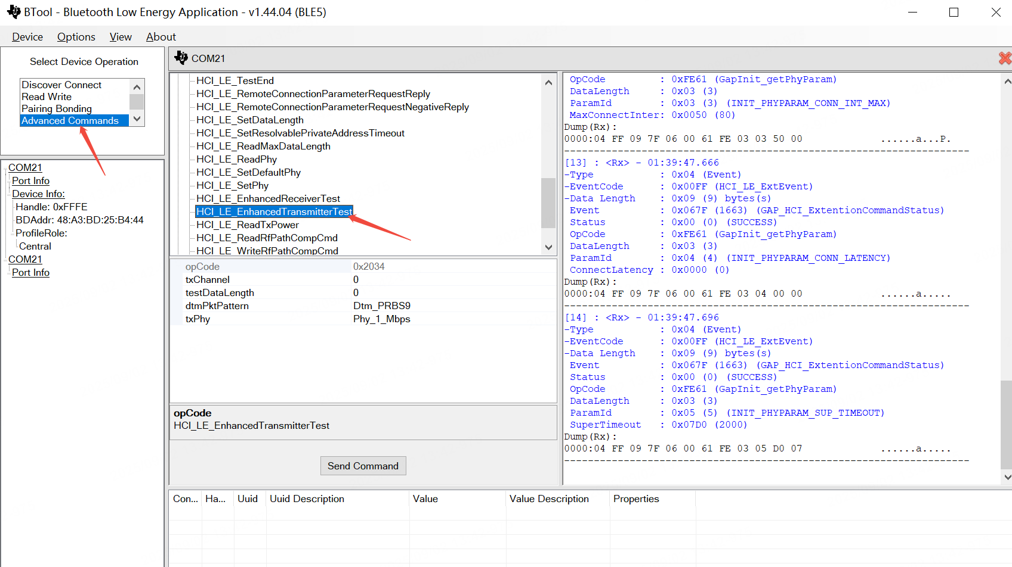
Before switching between transmit and receive parameter commands, you need to click HCI_LE_TestEnd.
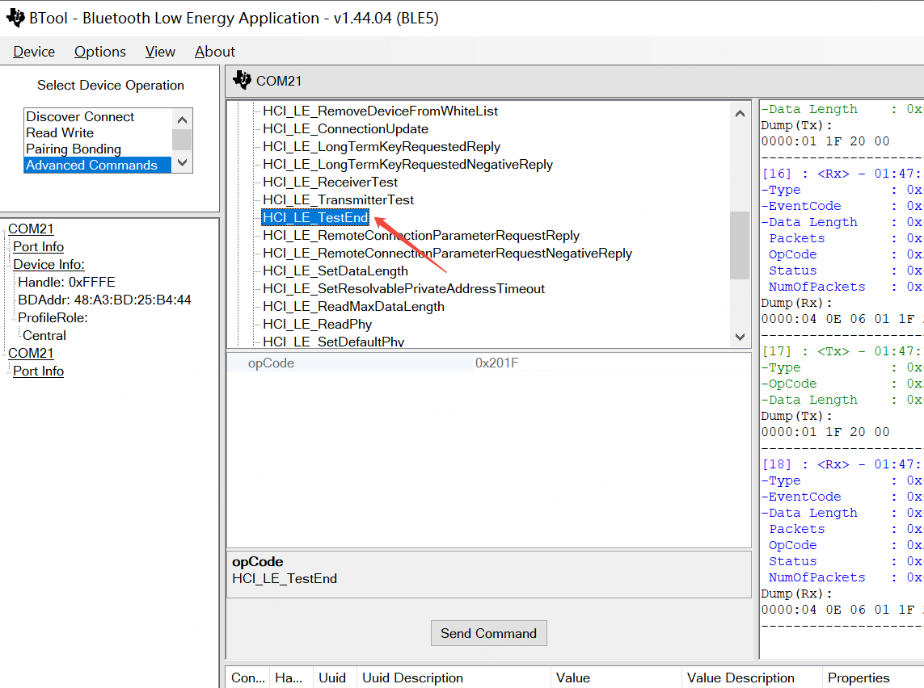
6. Receive Test: Click HCI_LE_EnhancedReceiverTest to enter receive mode. After the instrument sends a signal, click HCI_LE_TestEnd. The return value of the command includes the number of received packets. As shown in the figure, you can see the number of packets received indicated by arrow 3 Calculate the packet error rate (PER):
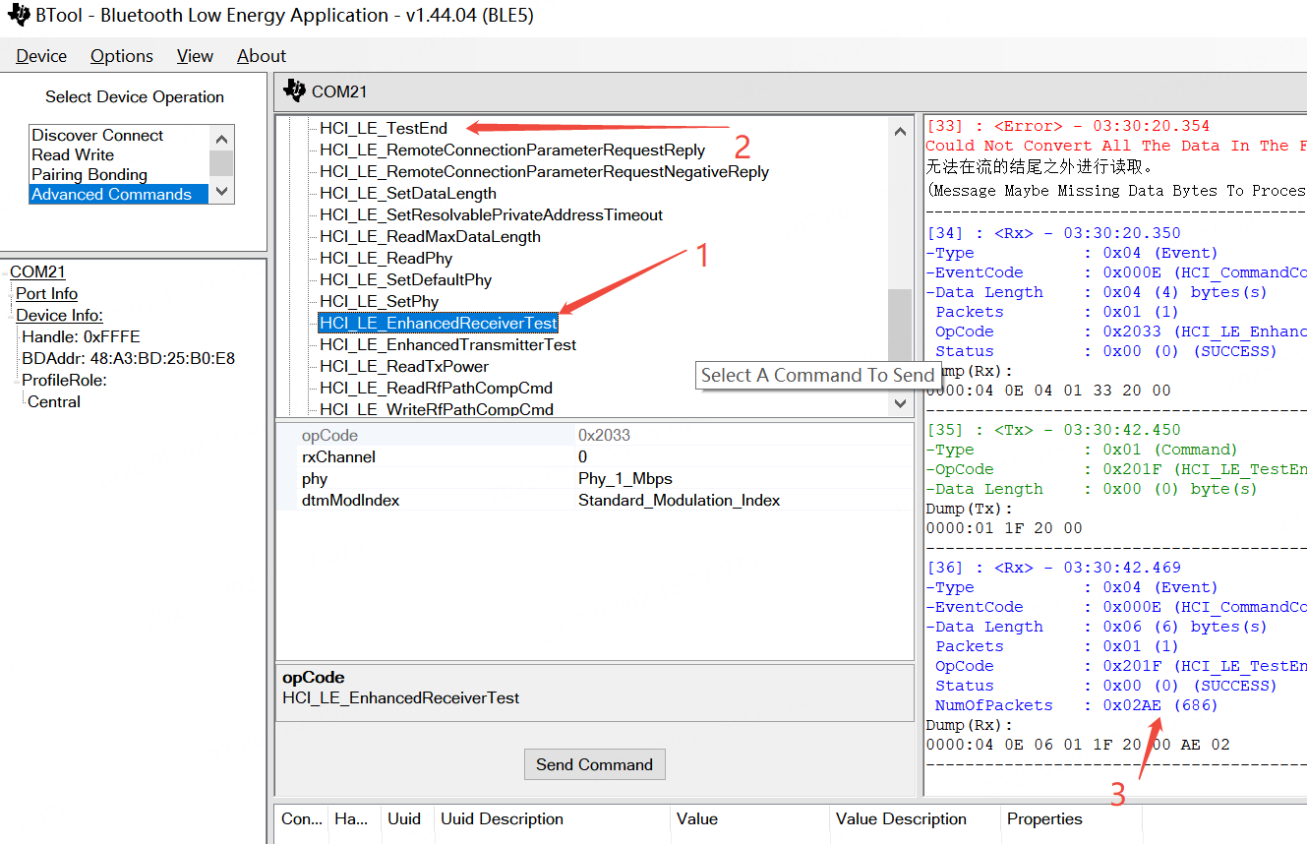
7. Single Carrier Test: Find HCI Extended, select HCIExt_ModemTestTxCmd, set cmMode to HCI_EXT_TXUNMODULATED_CARRIER, modify the channel, and click Send Command to start the test.
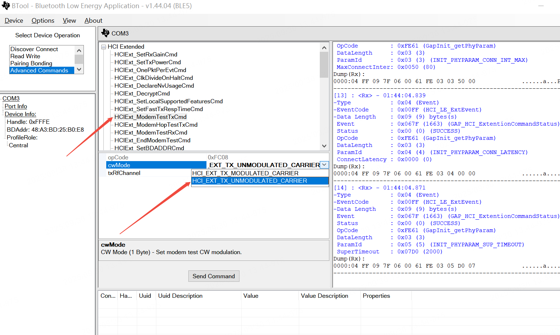

II. BQB Testing
1. Wiring
Module ------ Serial Port Board
VCC ------- 3.3V
GND ------- GND
IO22 ------- TX
IO20 ------- RX
2. Connect the serial port board to CMW500 for signaling connection, select HCI protocol, baud rate 115200

