MDWBRCU1

Content

1.Wiring explanation 1
2.Wi-Fi (b/g/n20) fixed frequency testing 2
3.Bluetooth (BLE 1M) fixed frequency testing 5
4.Wi-Fi adaptive testing 10

1.Wiring explanation
1.1 Module welding position
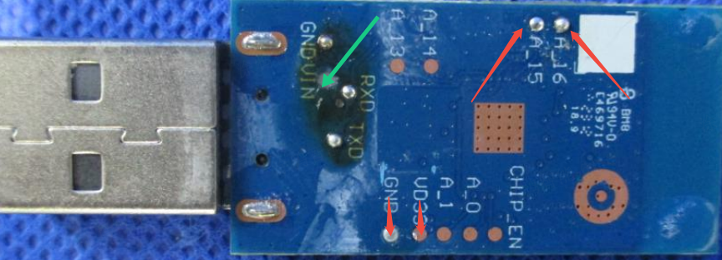
1.2 Module --Connect -- UART Board(TX\RX is reversed)
A_16 – RX
A_15 – TX
VD33 – 3.3V
GND – GND

Note：If the Vin of the module is soldered with DuPont wire, the Vin needs to be connected to the 5V of the UART.

1.3 The UART is used as follows:
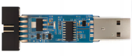
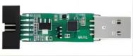

Generally, tests can also use other UART.

2.Wi-Fi (b/g/n20) fixed frequency testing
2.1 Fixed frequency module is connected to UART, and UART is plugged into the PC.
UART driver：(If the PC already has a driver, do not install it)
Right-click and select Save to file
2.2 Using the “MP Tool”
Double-click to download, or right-click and select Save to file
2.3 Opening the Tool，Click Initialize,The View Window has no log information
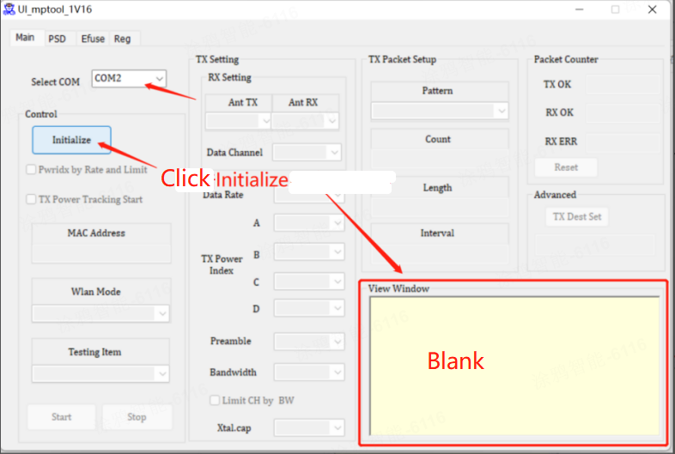
2.4 Read Efuse：
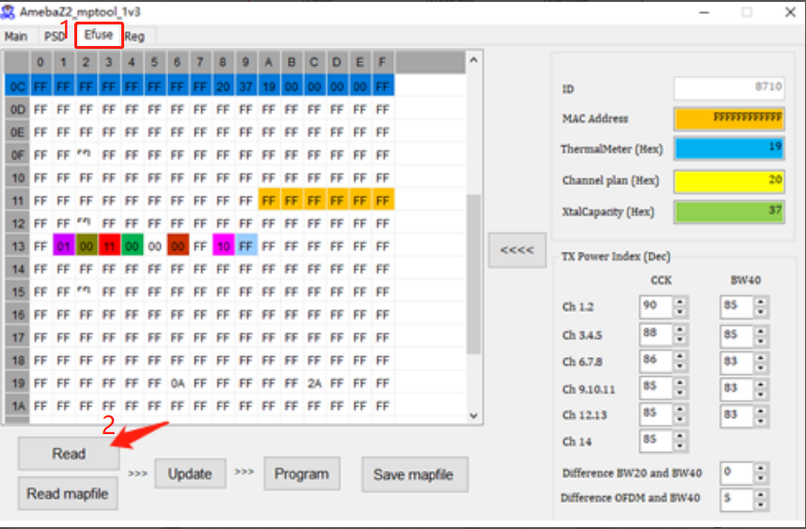
2.5 Change the register line 13 and row 1, “01” change to “00”, follow the step of 1-2-3.
(If Efuse is 00, you do not need to perform this operation)
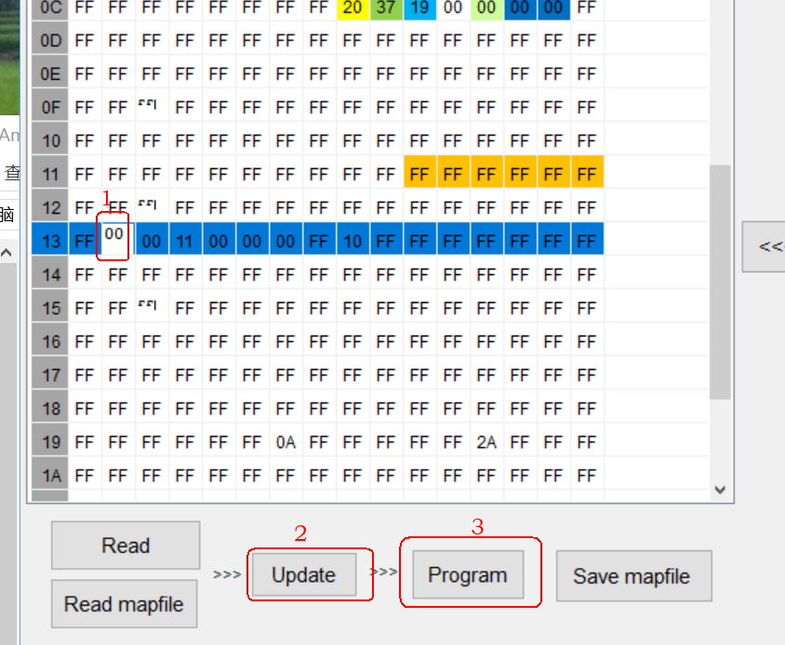
2.6 Close and re-open the software, Select COM, Click Initialize, Click Efuse，Click Read, you can find 13 line 1 row has changed to“00”.
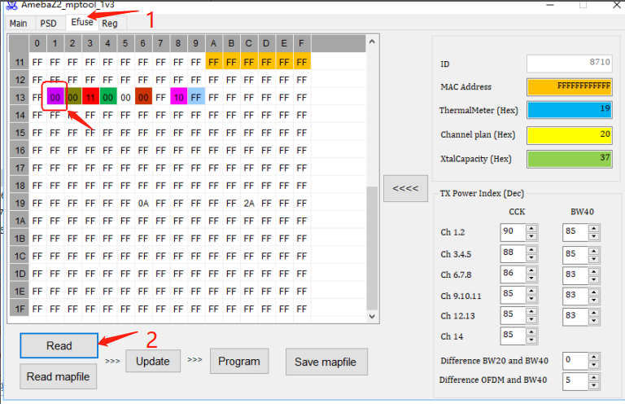
2.7 Click Main: Ant TX, select A, set Channel, Rate, Index to adjust the power (in the blue column). Select Packet TX and click Start Test
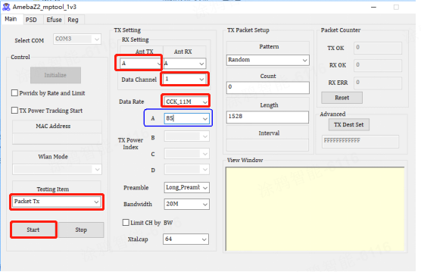
If the test data is different from the module technical specifications, please adjust the power index according to the product specifications
dBm |  | Power index（For reference only）
11b | 1M：17 | 1M：82
11g | 6M：15 | 6M：88
11n | MCS0：14 | MCS0：84
2.8 Frequency error test: Select Channel,Testing Item Select Single Tone TX,click Start to test.If the tests fail, you can click Stop ,adjust Xtalcap,click start.
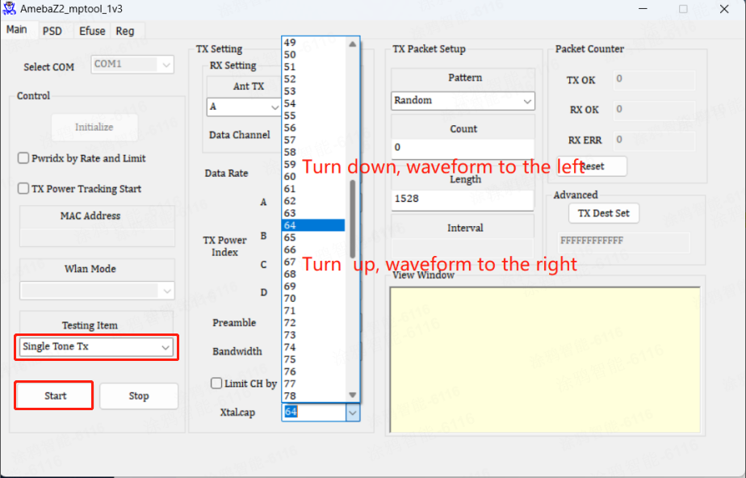
2.9 RX test: Testing Item Select Packet RX, click Start to test.
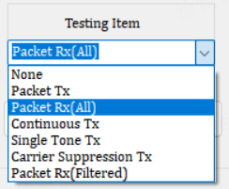

3.Bluetooth (BLE 1M) fixed frequency testing
3.1 Fixed frequency module is connected to UART, and UART is plugged into the PC.
3.2 Double-click to download, or right-click and select Save to file
3.3 Enter the following commands in SSCOM; follow the step of 1-2-3-...-6;
ATM2=bt_power,on
ATM2=gnt_bt,bt
ATM2=bridge
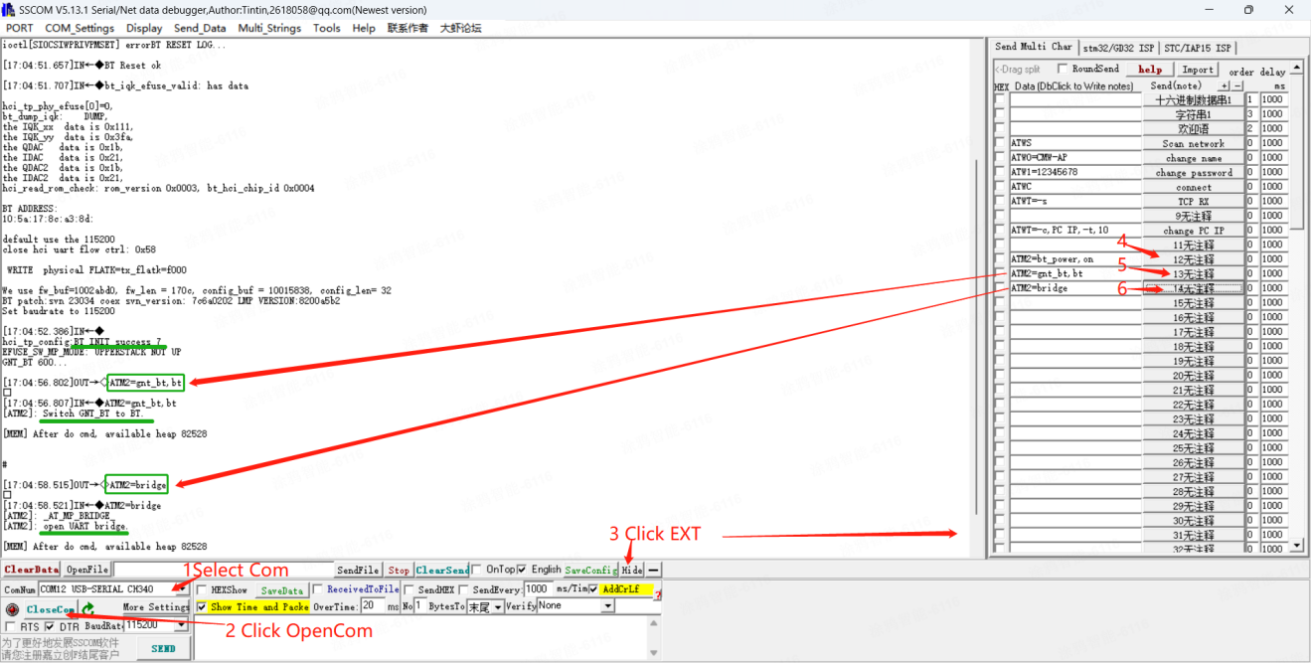
3.4 Close the SSCOM tool;Do not remove the UART
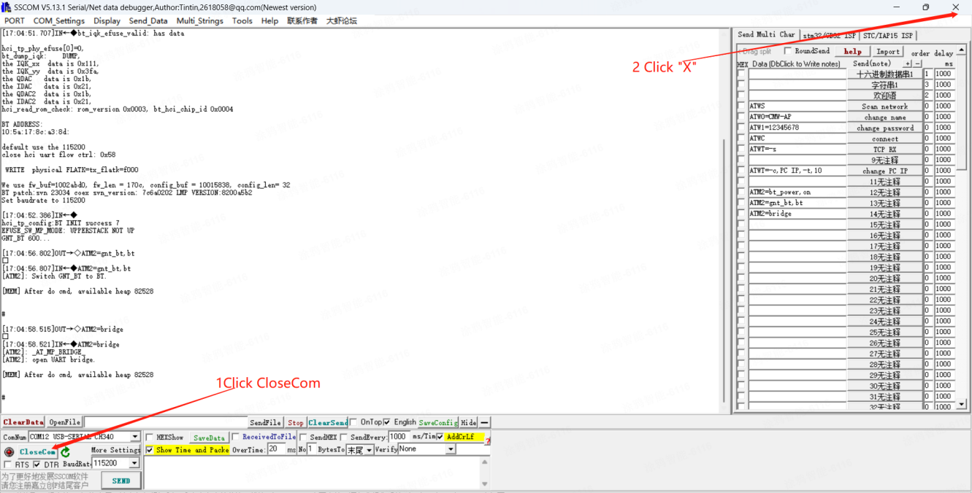
3.5 Use the RTLBTAPP Tool
Double-click to download, or right-click and select Save to file
3.6 Operate as the administrator：RTLBTAPP.exe
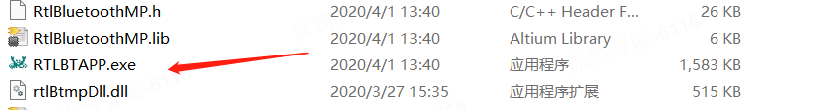
3.7 Follow the order of 1-2-3-4, open the tool, open the up-left which is in green。
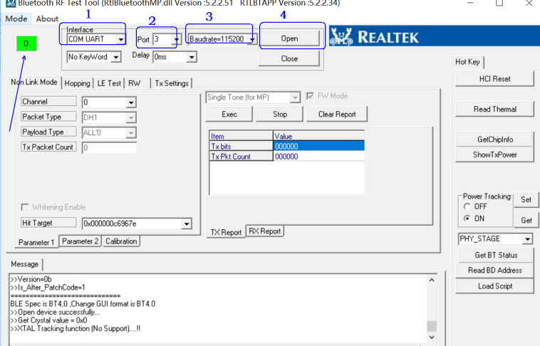
3.8 Follow the order of 5-6-7：
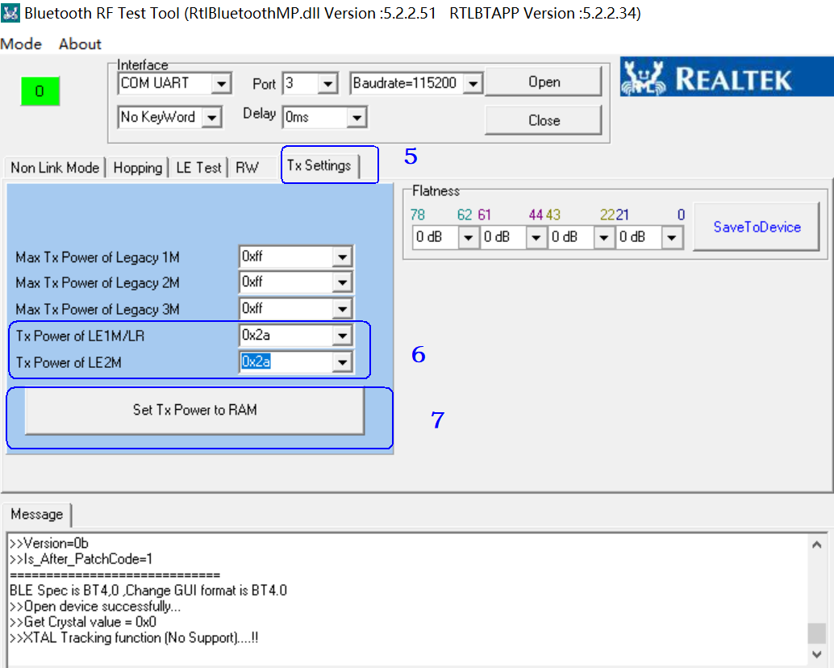
3.9 Follow the order of 8-9-10-11, among them 10 places are the Index value of adjusting the power, the initial value can be set as 08(around 7dbm), lower the power to set 07 or 06. Increase the power to set 09 or 10, the default power is 7±1dbm。
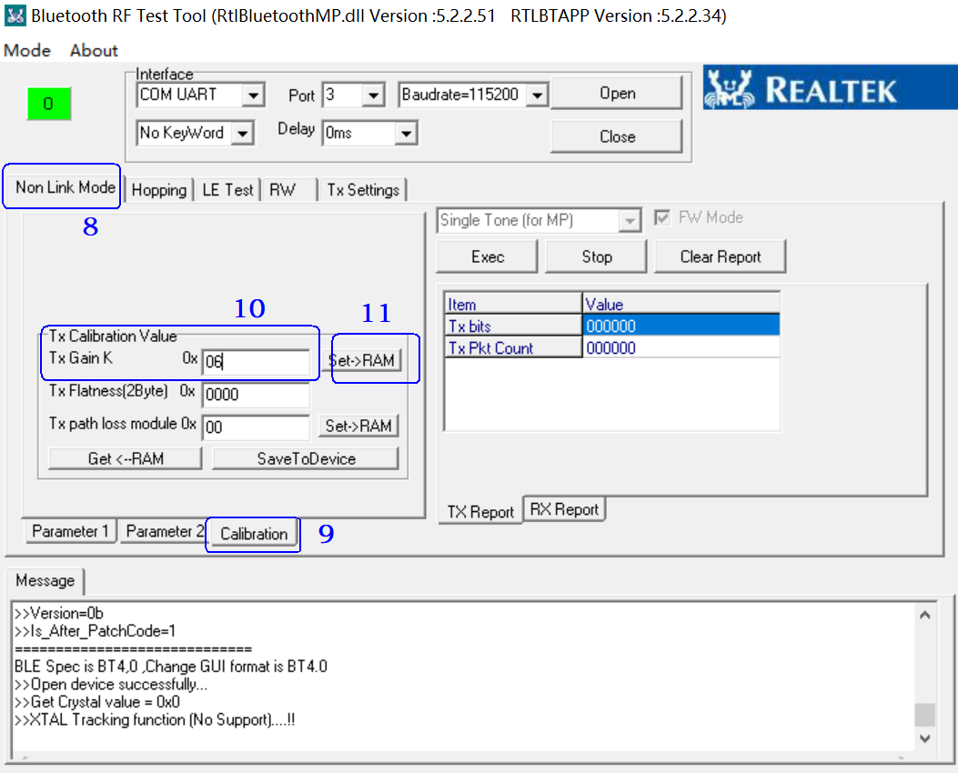
3.10 Follow the order of 12-13-14-15，in 13 chose Tx ，14 chose channel, click 15 to start testing。
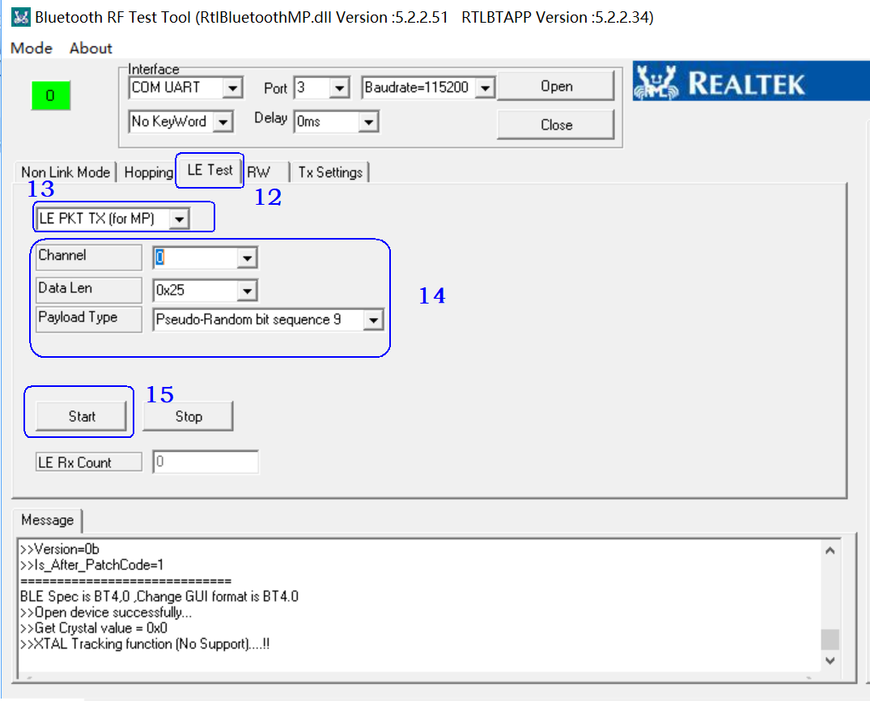
3.11 Frequence error (Single carrier) test：
a).If the power is not powered off, Turn off the BLE RF test tool and open it again. directly follow the settings in the following figure, you can change Channel in 3
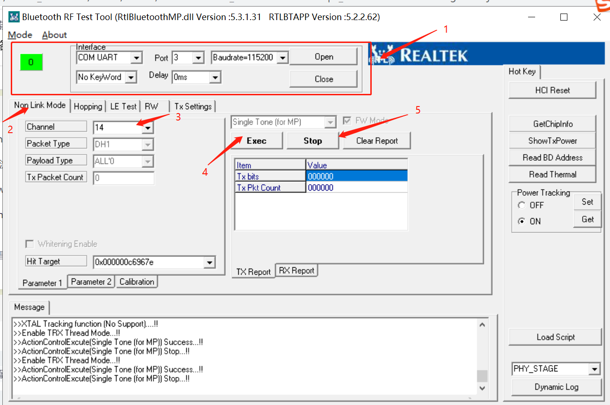
b).If the power is off, after connecting the UART,
- Use the SSCOM tool to enter the following commands:
ATM2=bt_power,on
ATM2=gnt_bt,bt
ATM2=bridge
- Close the SSCOM tool;Do not remove the serial port board. Open the RTLBTAPP Tool and follow the above picture.
3.12 RX Test
The remaining steps are the same as before. Select LE PKT RX for Items only.
Click Start to test.
Examples are shown below:
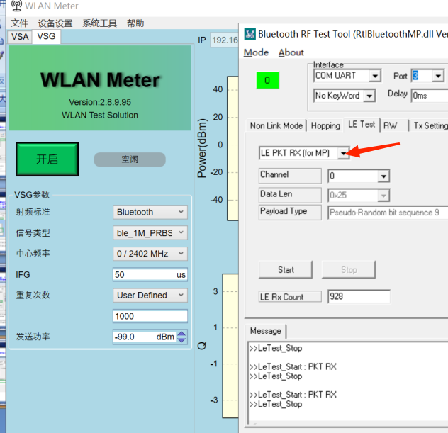

4.Wi-Fi adaptive testing
4.1 The adaptive module is connected to the UART, plugged into PC
4.2 Double-click to download, or right-click and select Save to file
4.3 Select Com, Click OpenCom, Click EXT
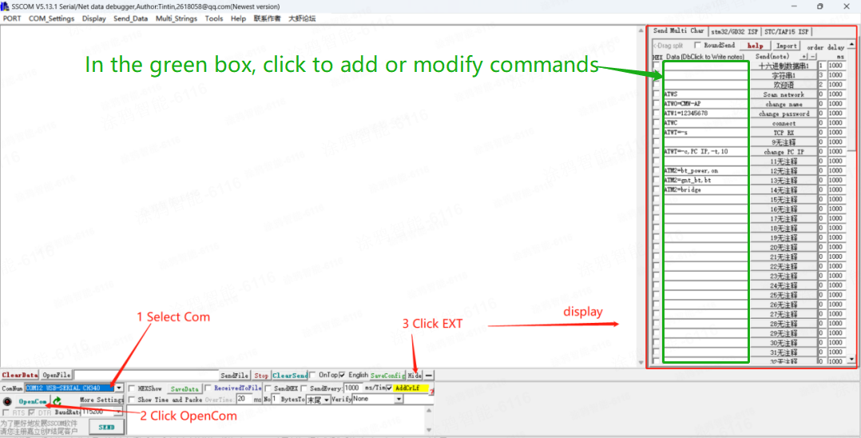
4.4 RX Test
1)SSCOM send commands：
ATWS （Scan the nearby AP hotspot）
ATW0=SSID （SSID:AP name, such as : ATW0=CMW-AP）
ATW1=password （Enter the password corresponding to the SSID,such as : ATW1=12345678）
ATWC （Connect AP）
Note: The SSID and password are changed according to the actual conditions
2)After the ATWC is sent, the AP is connected successfully and the module IP is obtained
SSCOM send commands：ATWT=-s
as shown below
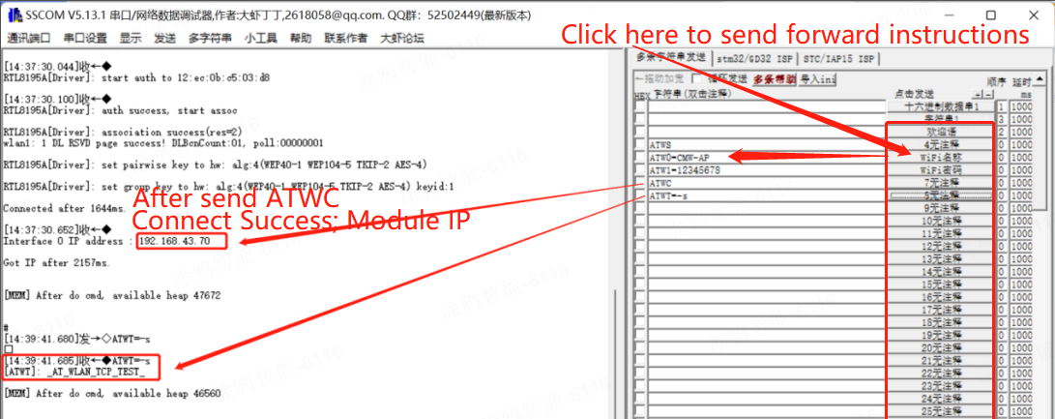
3)The PC (-c) connects to a hotspot on the same router. After the connection is successful, you can view the PC IP address through network attributes.
Note: The router should be set up in 2.4G network and can be used normally;
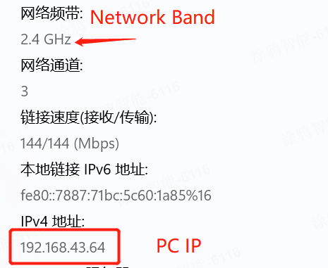
- Download iperf software to desktop
Double-click to download, or right-click and select Save to file
5)Run CMD in administrator mode；
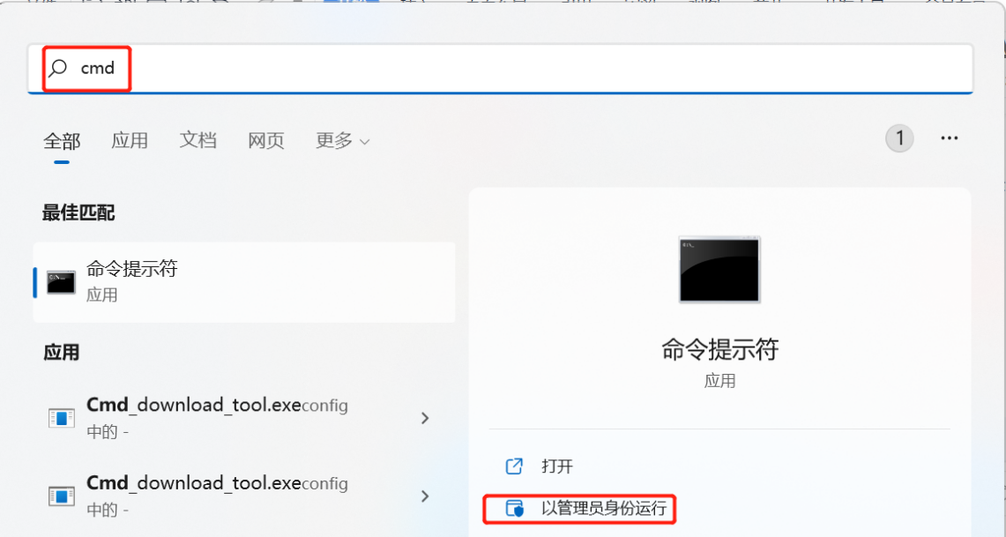
6)Find the following file in the zip package you just downloaded；
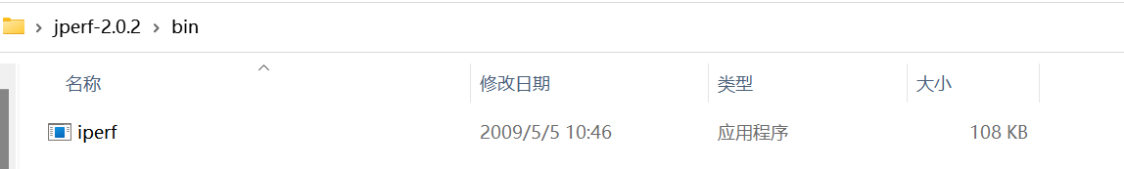
7)Click and paste the copy path; And then I put cd in front of that path；
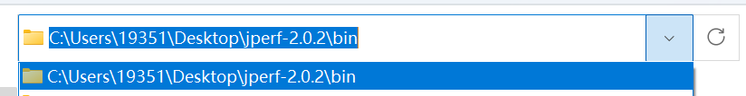
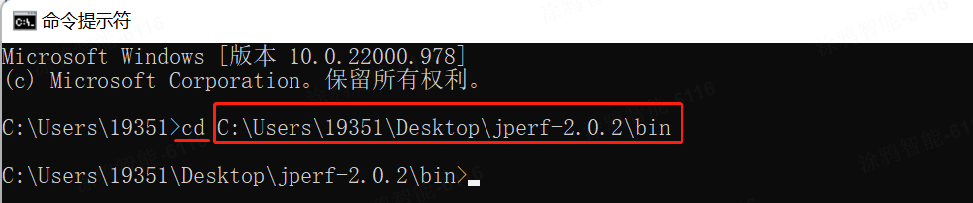
8)Continue to send commands: iperf.exe -c module IP -i 1 (interval 1S) -t 10(packet quantity 10)
Space between fields; Package quantity changes according to test
For Example：iperf.exe -c 192.168.43.70 -i 1 -t 10
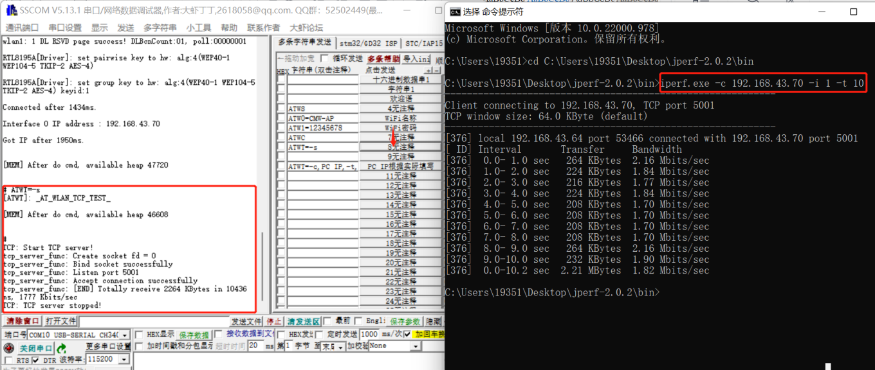
4.5 TX Test
1)Module：SSCOM send commands：
ATWS
ATW0=CMW-AP
ATW1=12345678
ATWC
2)PC(-s) CMD, cd path, (same as the previous steps), enter the command：iperf.exe -s -i 1
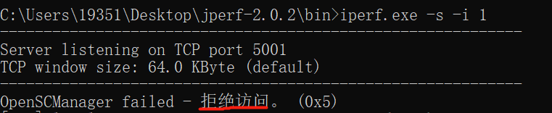
The presence of "拒绝访问" does not affect testing。
3)Module: SSCOM Send commands
ATWT=-c,PC IP,-t,10 (Package quantity 10,Package quantity changes according to test)
For Exmple：ATWT=-c,192.168.43.64,-t,10 （The PC IP viewed in the previous step）
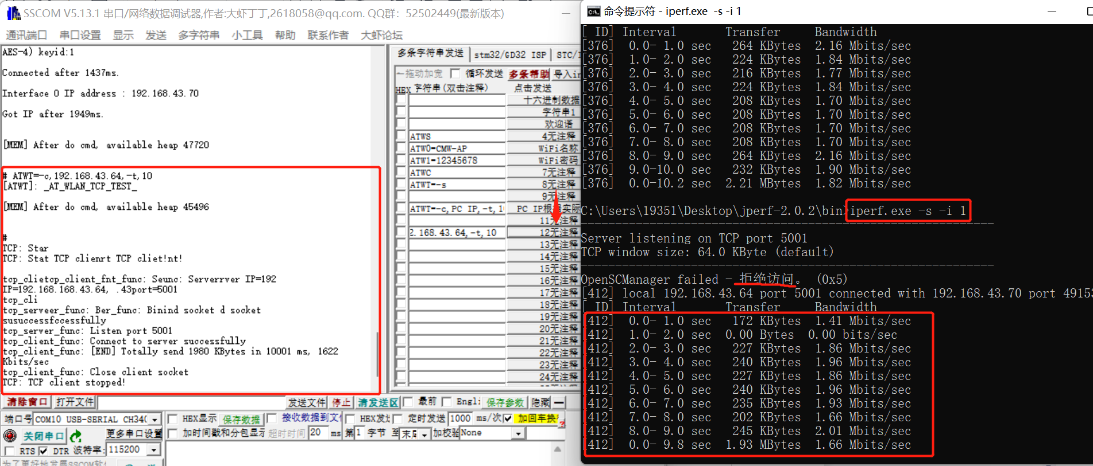
If you want to stop the current connection, pls insert the below commands: ATWD

