WR11-2S,WR11-3S,WR11-U,WR11-U-IPEX

Content

1.Wiring explanation 1
2.Wi-Fi fixed frequency testing 2
3.BT (BLE) fixed frequency testing 4
4.Wi-Fi adaptive testing 7

1.Wiring explanation
1.1 Module welding position
WR11-2S WR11-3S WR11-U、WR11-U-IPEX
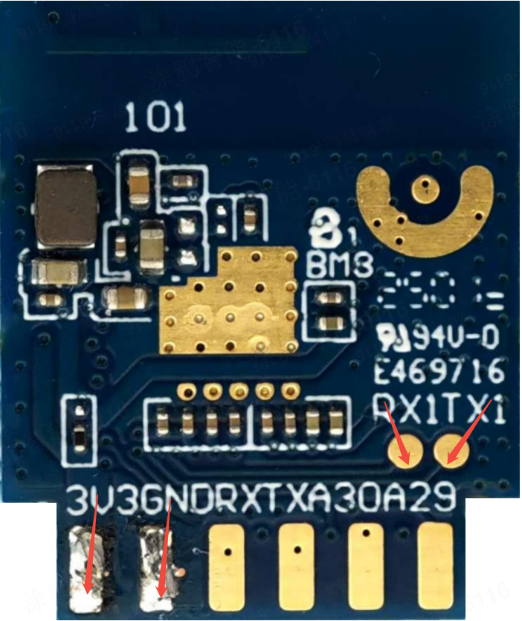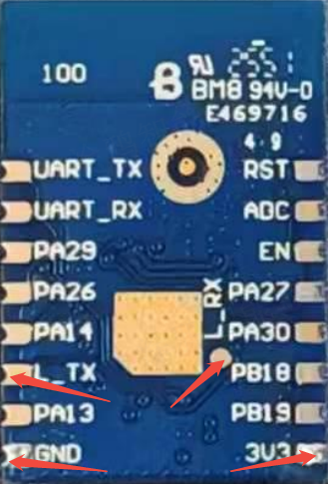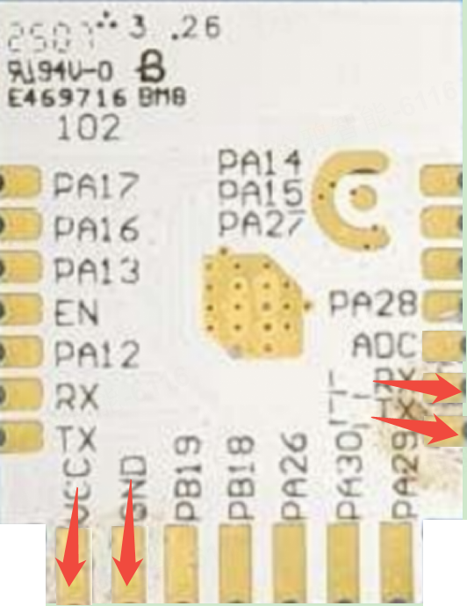
1.2 Module --Connect -- UART Board(TX\RX is reversed)
TX1 / L_TX ––– RX
RX1 / L_RX ––– TX
3V3/ VCC ––– 3.3V
GND ––– GND
1.3 For example: WR11-2S
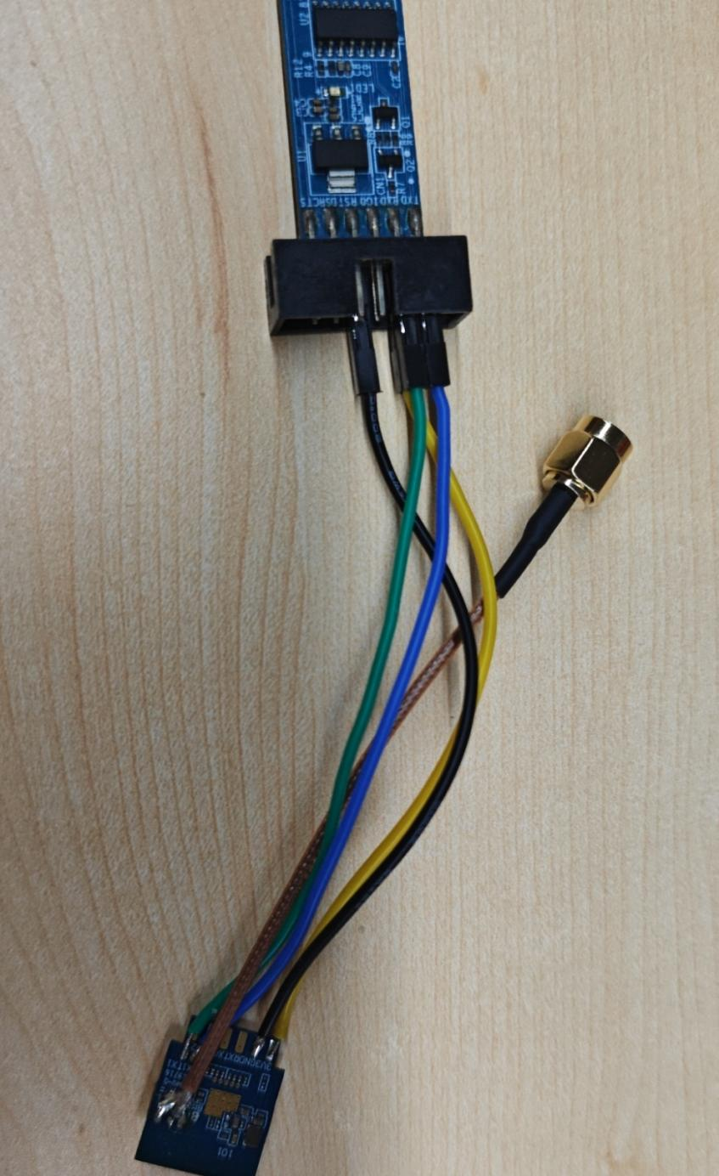

2.Wi-Fi fixed frequency testing
2.1 Fixed frequency module is connected to UART, and UART is plugged into the PC.
UART driver：(If the PC already has a driver, do not install it)
Double-click to download, or right-click and select Save to file
2.2 Using the “MP Tool”
Double-click to download, or right-click and select Save to file
2.3 Opening the Tool,Follow the order of 1-2-3,The View Window has no log information
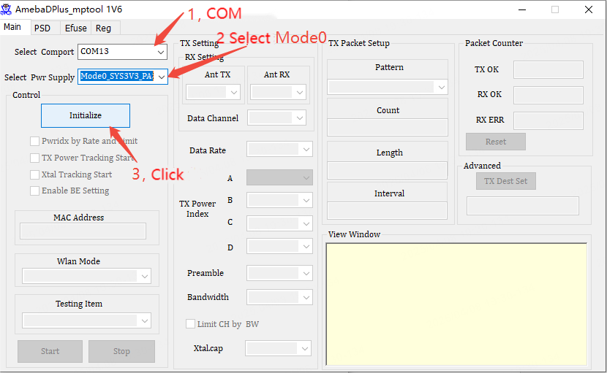
2.4 Ant TX: select A, set Channel, Rate,set power Index to adjust the power . Select Packet TX and click Start to test
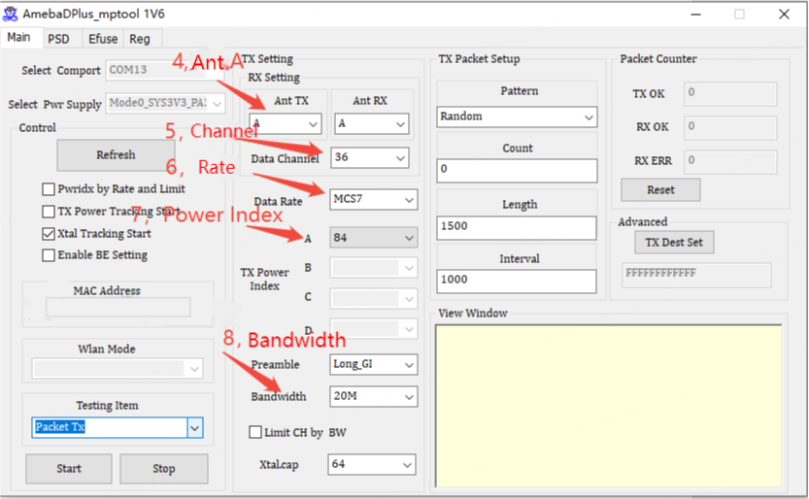
Power Index is for reference only.
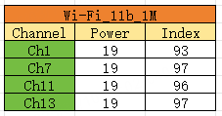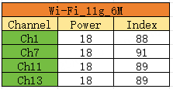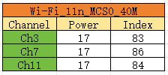
2.5 Frequency error test: Select Channel,Testing Item Select Single Tone TX,click Start to test.If the tests fail, you can click Stop ,adjust Xtalcap,click start.

2.6 RX test: Testing Item Select Packet RX, click Start to test.

3.BT (BLE) fixed frequency testing
3.1 The module connects to UART and inserts the UART into the computer's USB port.
3.2 Double-click to download, or right-click and select Save to file
3.3 Enter the following commands in SSCOM; follow the step of 1-2-3-...-7;
iwpriv mp_start
ATM2=bt_power,on
ATM2=gnt_bt,bt
ATM2=bridge
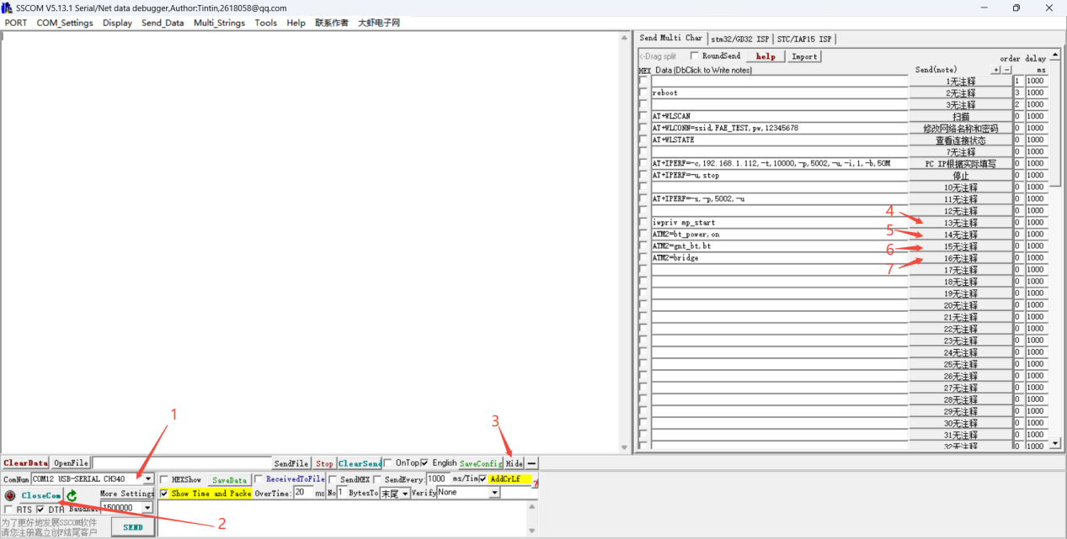
3.4 Close the SSCOM tool;Do not remove the UART, Use the RTLBTAPP Tool
Double-click to download, or right-click and select Save to file
3.5 Operate as the administrator：RTLBTAPP.exe. Follow the order of 1-2-3-4, open the tool, open the up-left which is in green.
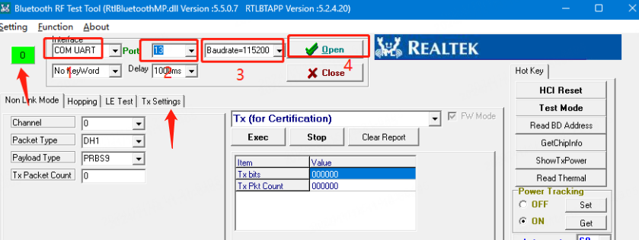
3.6 Follow the order of 5-6-7：
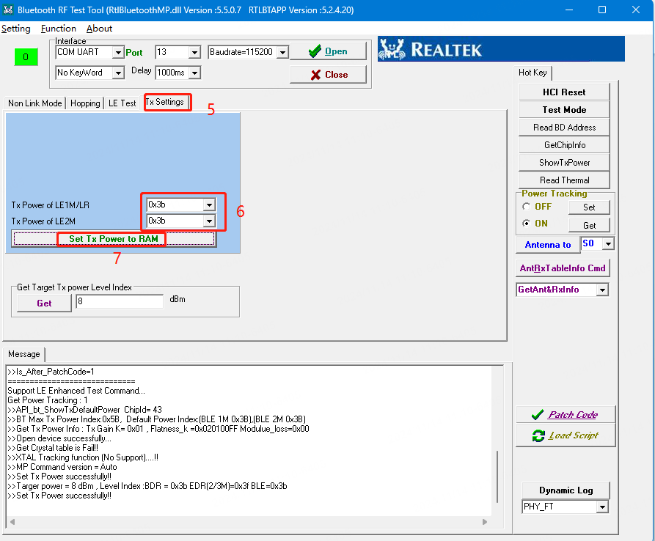
3.7 Follow the order of 8-9-10-11, among them 10 places are the Index value of adjusting the power.
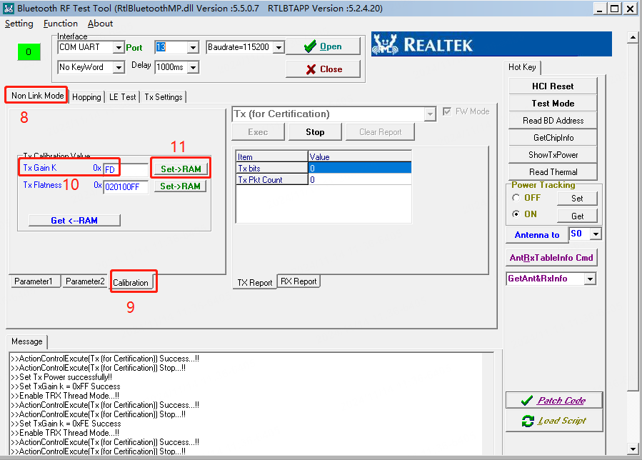
Power Index is for reference only.
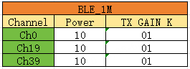
3.8 Follow the order of 12-13-14-15, in 13 chose Tx, 14 chose channel, click 15 to start testing.
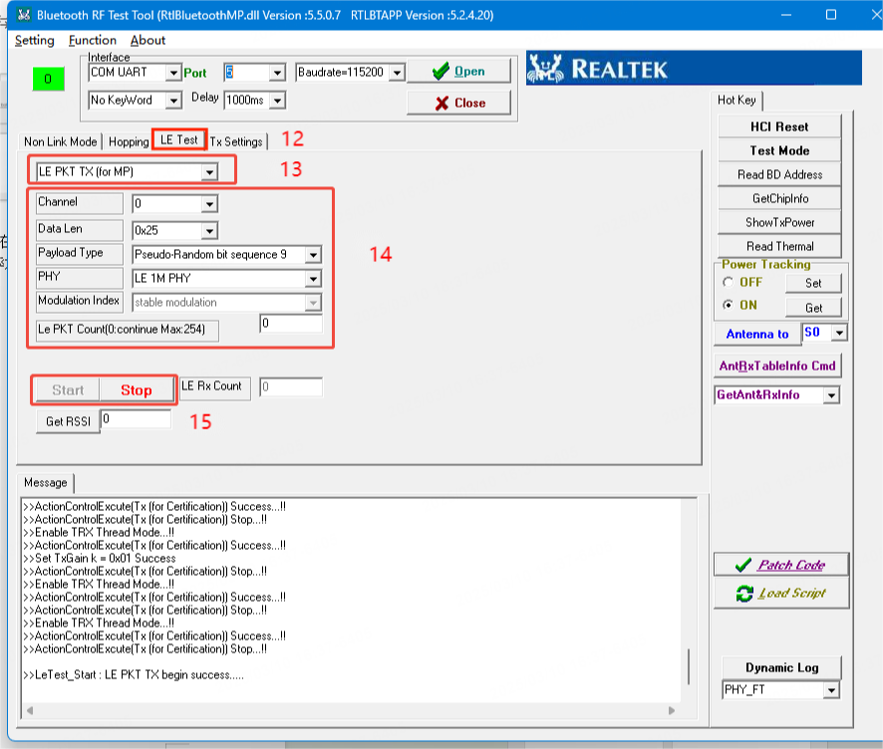
3.9Frequence error (Single carrier) test：
a).If the power is not powered off, directly follow the settings in the following figure, you can change Channel at position 3
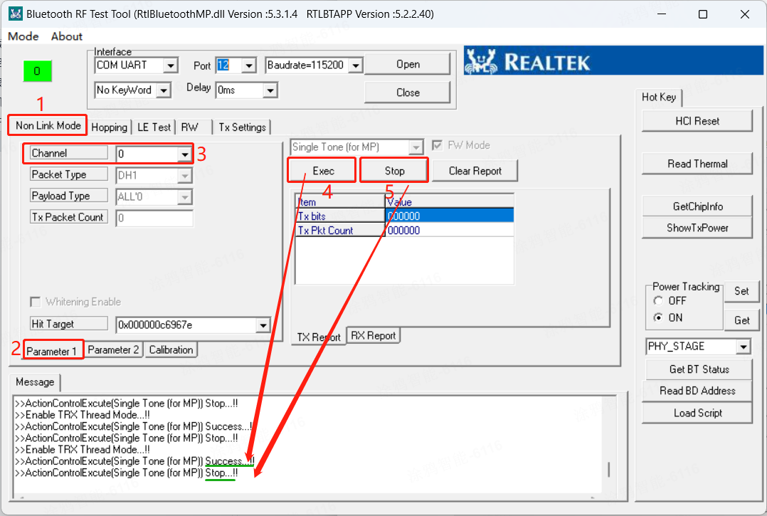
b).If the power is off, after connecting the UART,
- Use the SSCOM tool to enter the following commands:
iwpriv mp_start
ATM2=bt_power,on
ATM2=gnt_bt,bt
ATM2=bridge
- Close the SSCOM tool;Do not remove the serial port board. Open the RTLBTAPP Tool and follow the above picture.
3.10 RX Test
The remaining steps are the same as before. Select LE PKT RX for Items only.
Click Start to test.

4.Wi-Fi adaptive testing
4.1 The adaptive module is connected to the UART, plugged into PC.
4.2 Double-click to download, or right-click and select Save to file.(The Bluetooth frequency test has downloaded SSCOM. There is no need to download it again.)
4.3 Select Com, Click OpenCom, Click EXT.
Send the following commands to connect to the network
AT+WLSCAN // scan AP
AT+WLCONN=ssid,FAE_TEST,pw,12345678 //For example,SSID: FAE_TEST, password: 12345678
AT+WLSTATE //Check the connection
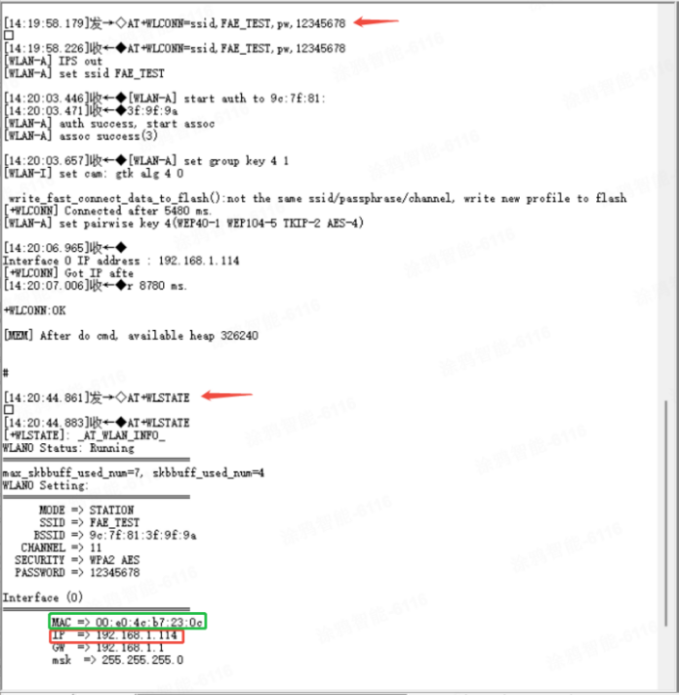
Note: The SSID and password are changed according to the actual conditions
As shown in the figure, module IP: 192.168.1.114
4.4Download iperf software to desktop
Double-click to download, or right-click and select Save to file
4.5Locate the file shown in the picture within the downloaded iperf compressed package; then click on the position shown in the picture and enter "cmd" and press Enter.
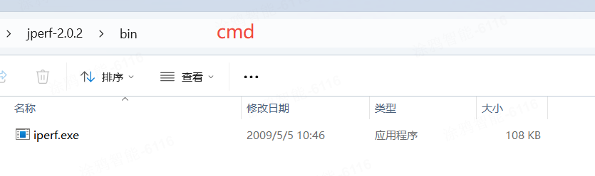
4.6 The PC is connected to the same router. On the PC side, check the IP address (enter "ipconfig" or look at the wireless network properties to find the IP address). Example: PC IP: 192.168.1.112
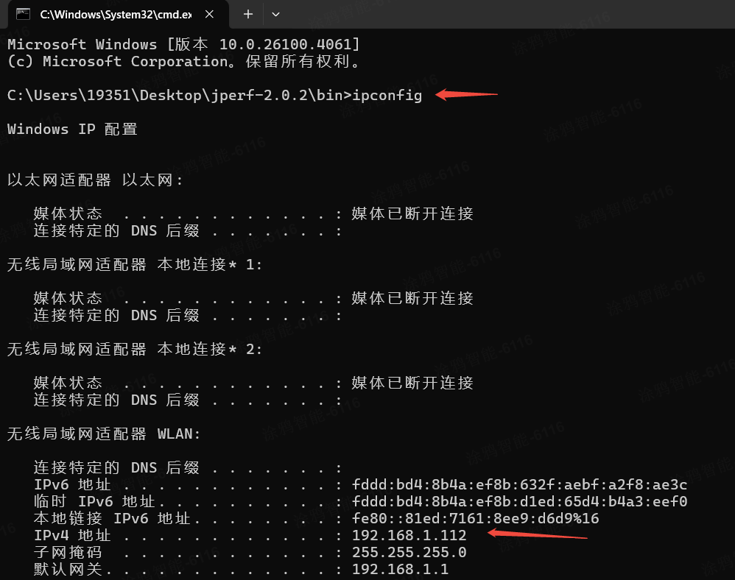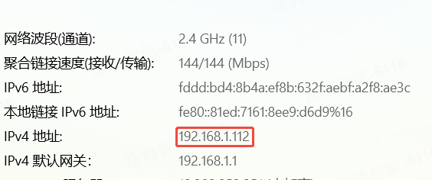
4.7 PC continue to send command: iperf -s -u -p 5002 -i 1
The module uses SSCOM to send command：AT+IPERF=-c,PC IP,-t,10000,-p,5002,-u,-i,1,-b,50M
For Example：AT+IPERF=-c,192.168.1.112,-t,30,-p,5002,-u,-i,1,-b,50M
